**Information Security Assignment #02**

**Muhammad Haziq Naeem**

**22I-1214  
 Testing and Evidence Report**

1. Wireshark:

Step 1: PKI Setup and Certificate Validation

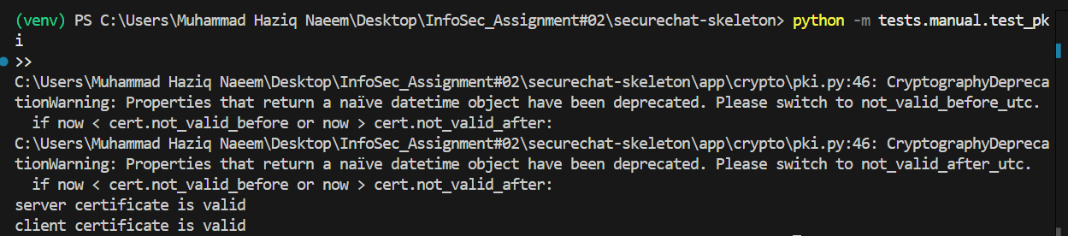

Step 2: Registration and Login

Server.py  
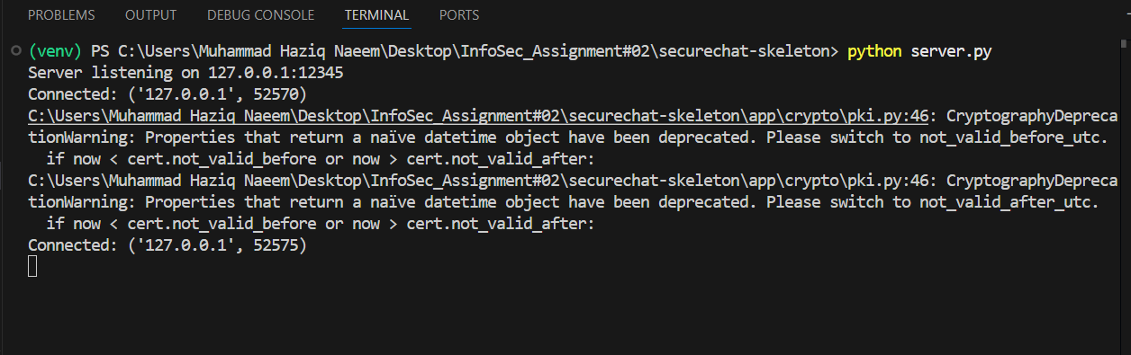

Client.py

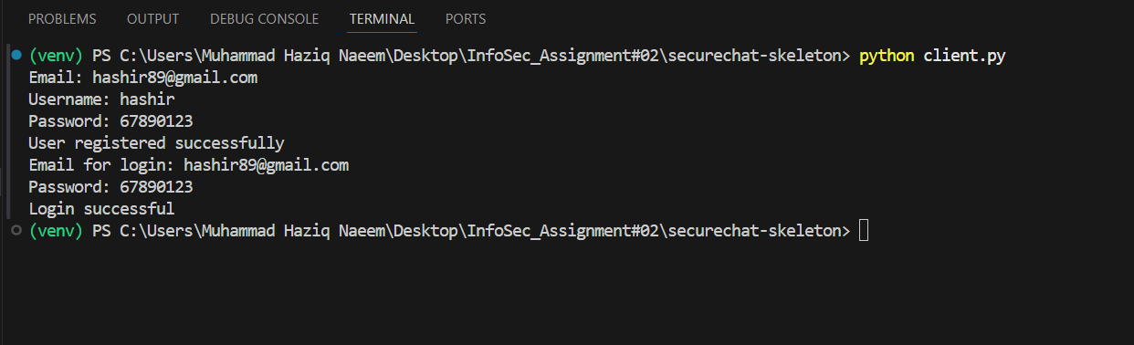

Wireshark:

Successful test

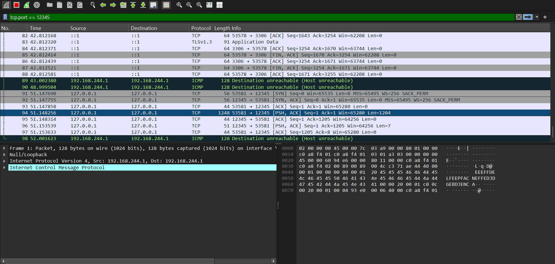

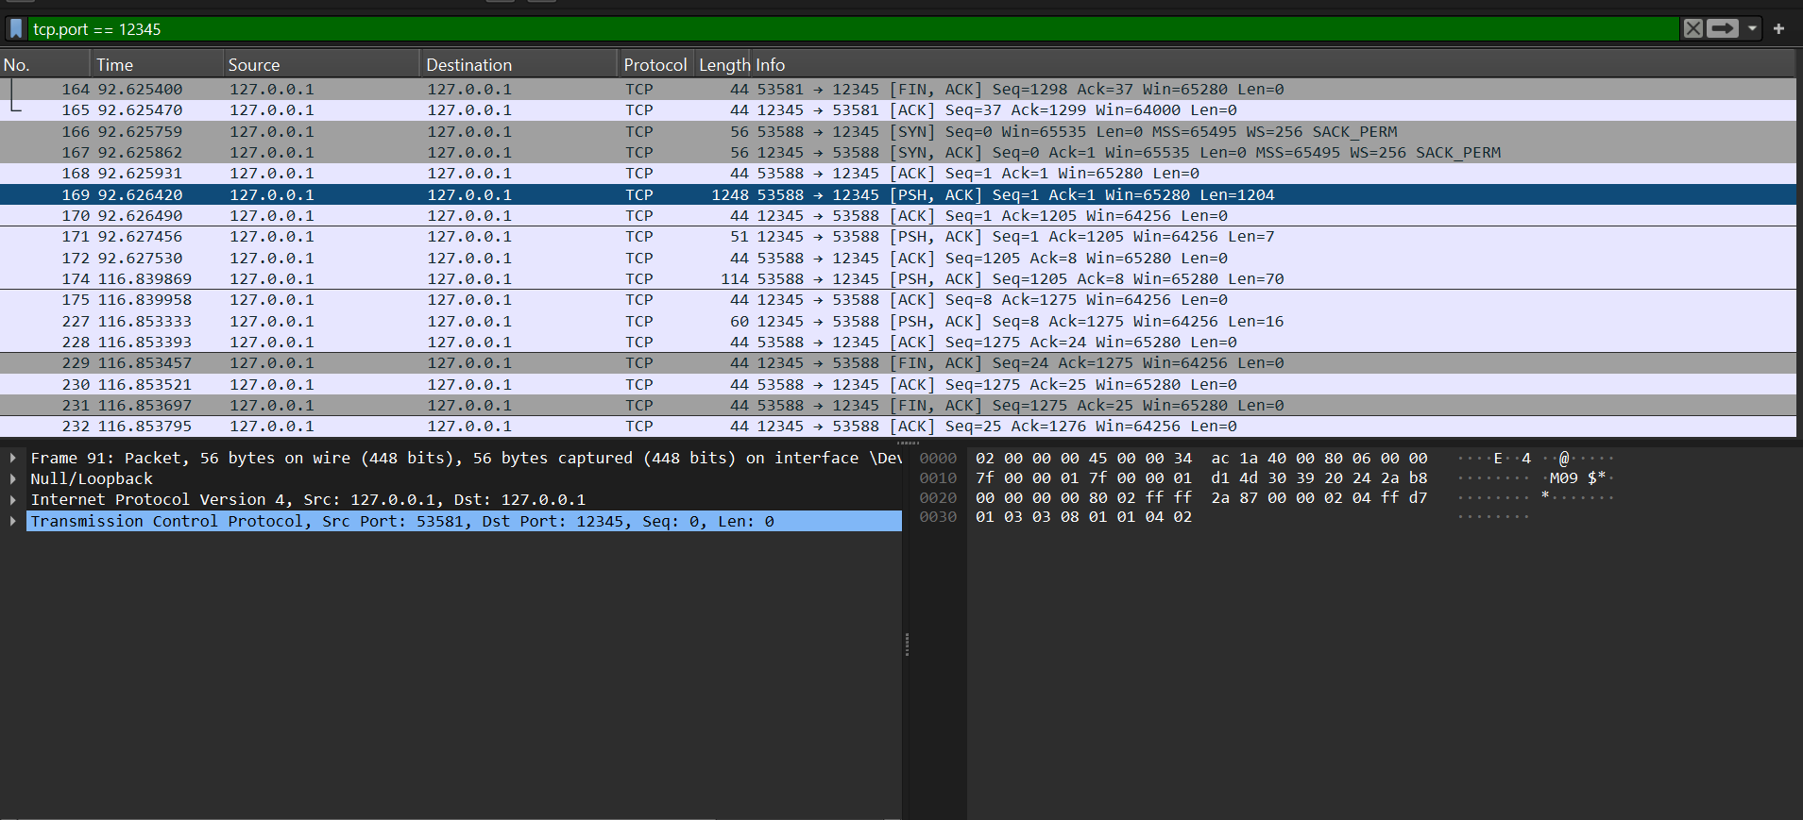

Unsuccessful test:  
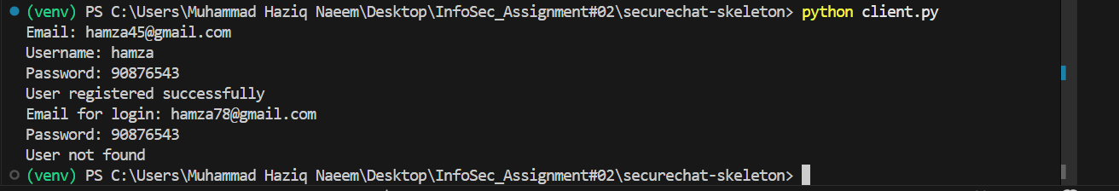

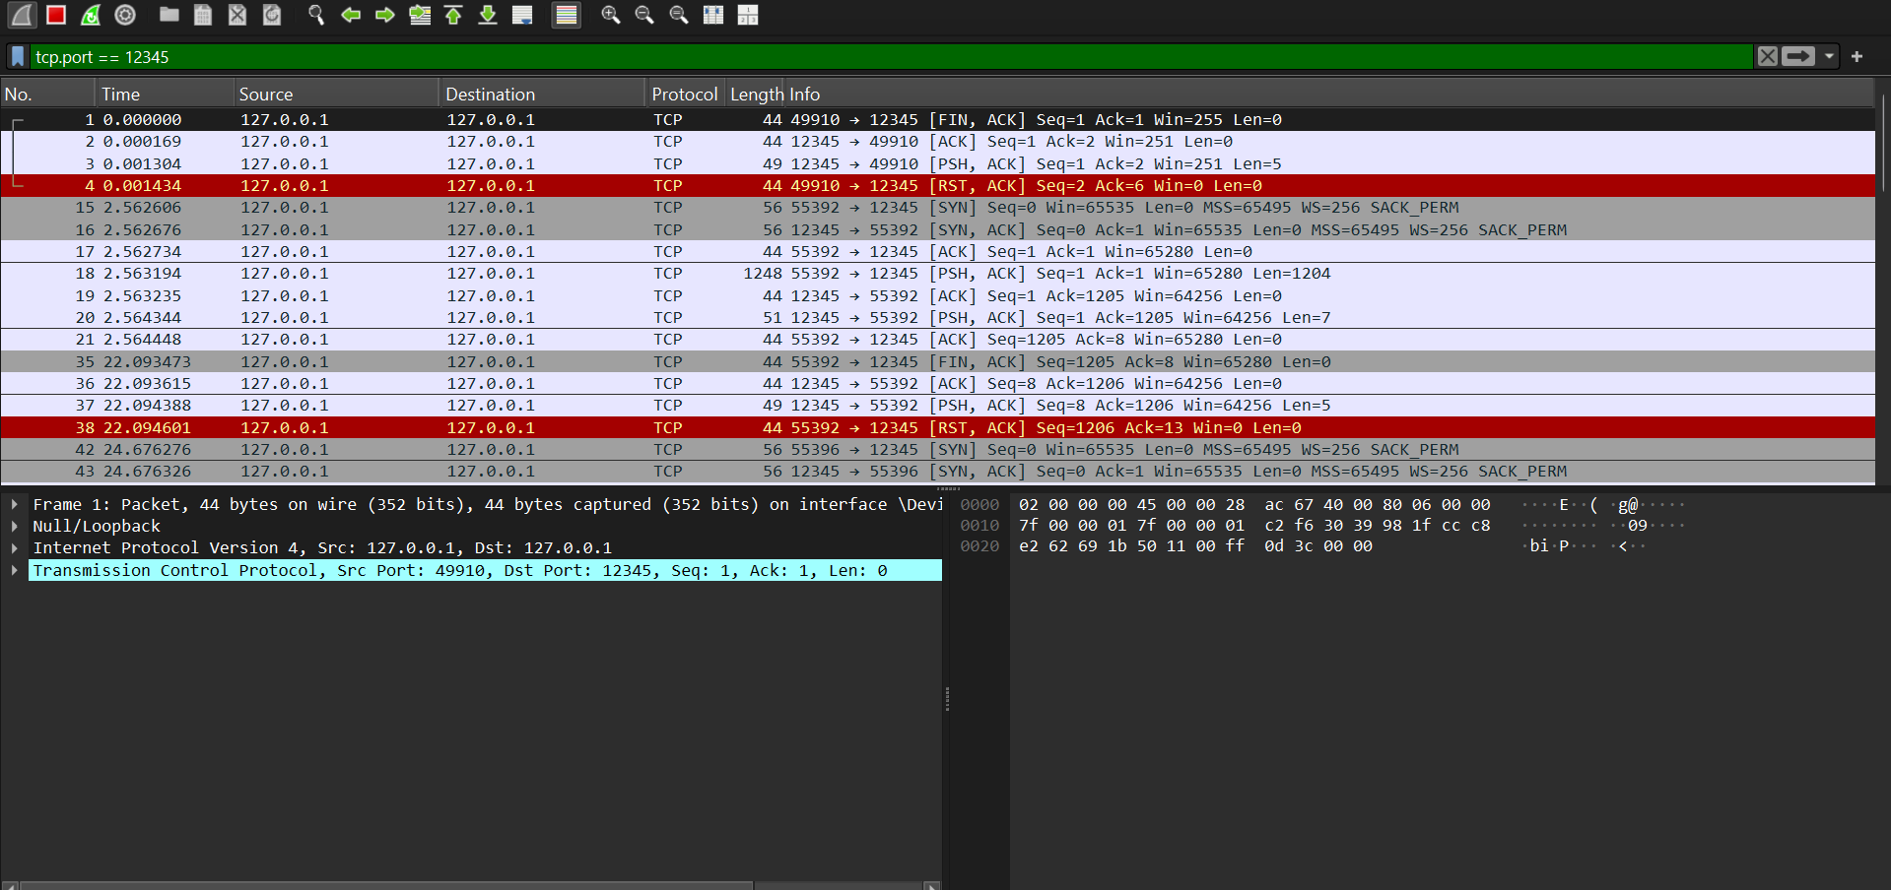

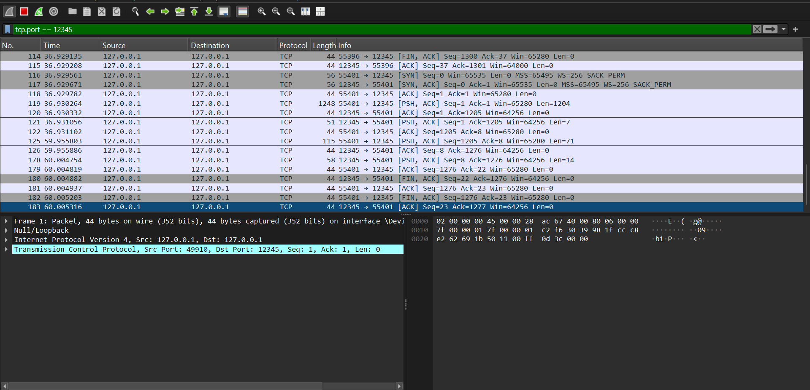

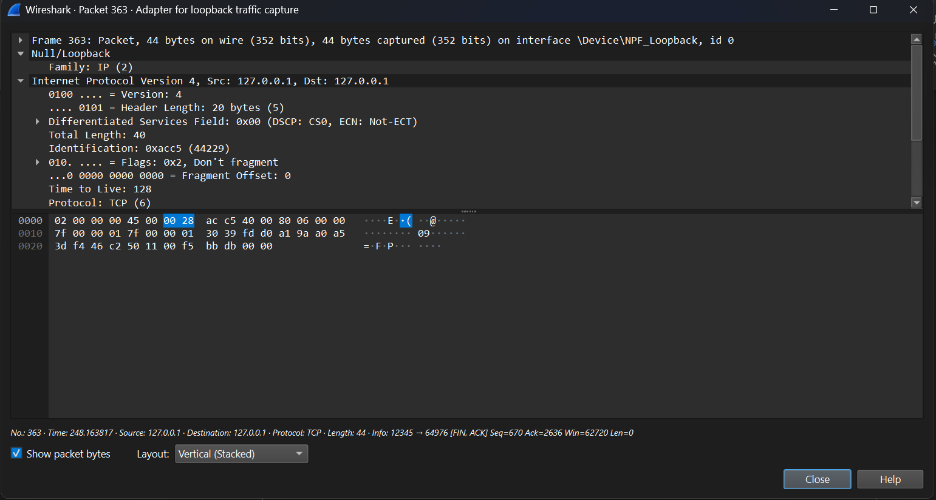

Step 2 (Screenshots):

Client_Certificate_Sent:

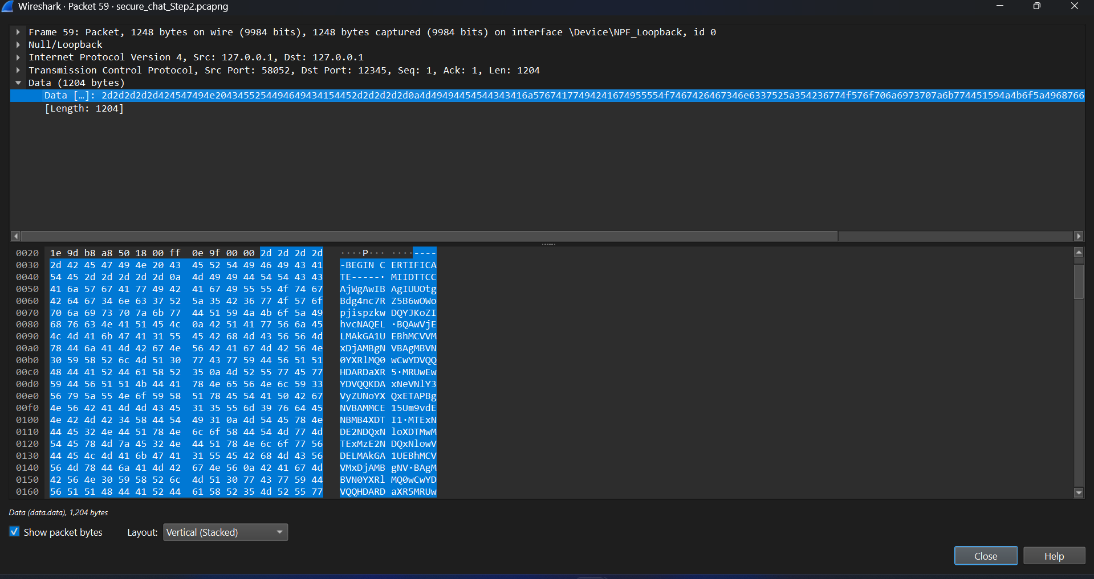

DH_Key_Exchange:

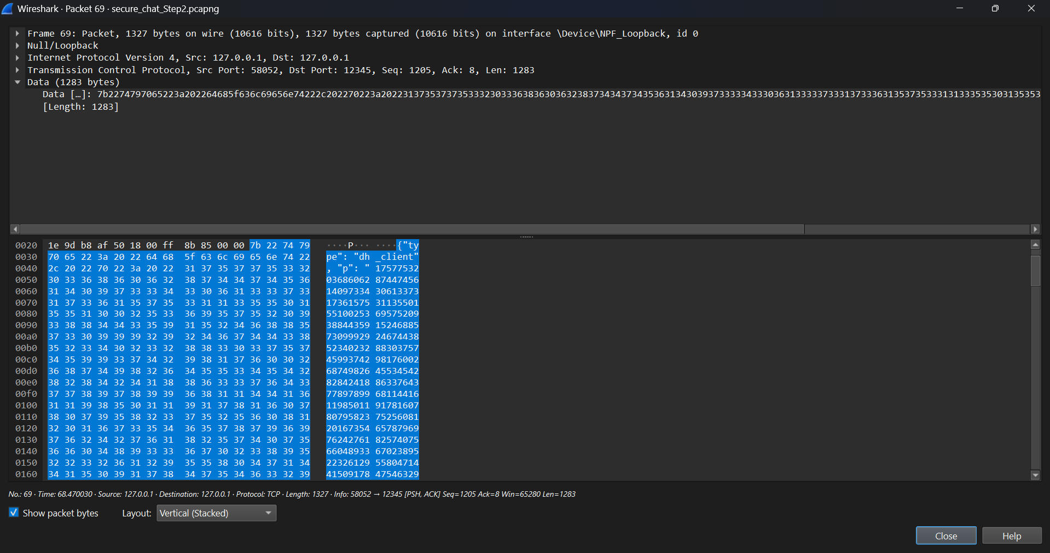

Client_Registration_Payload:

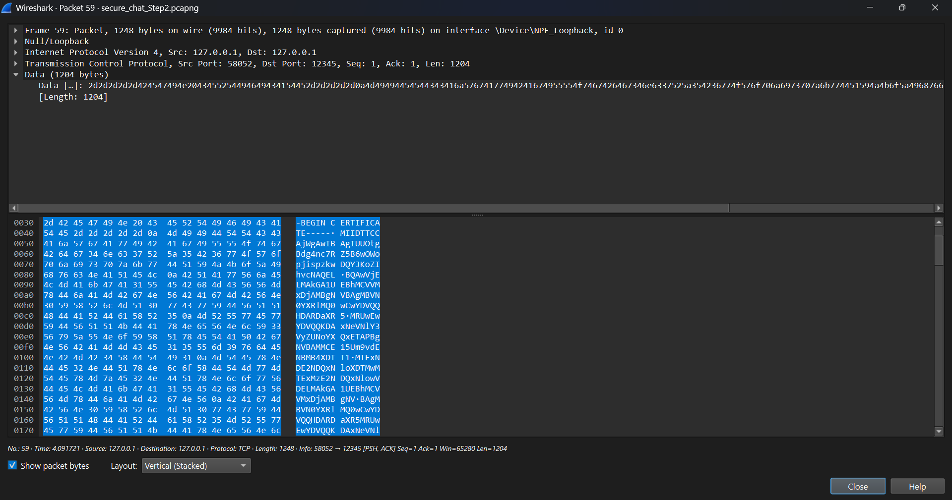

Server_Registration_Response:

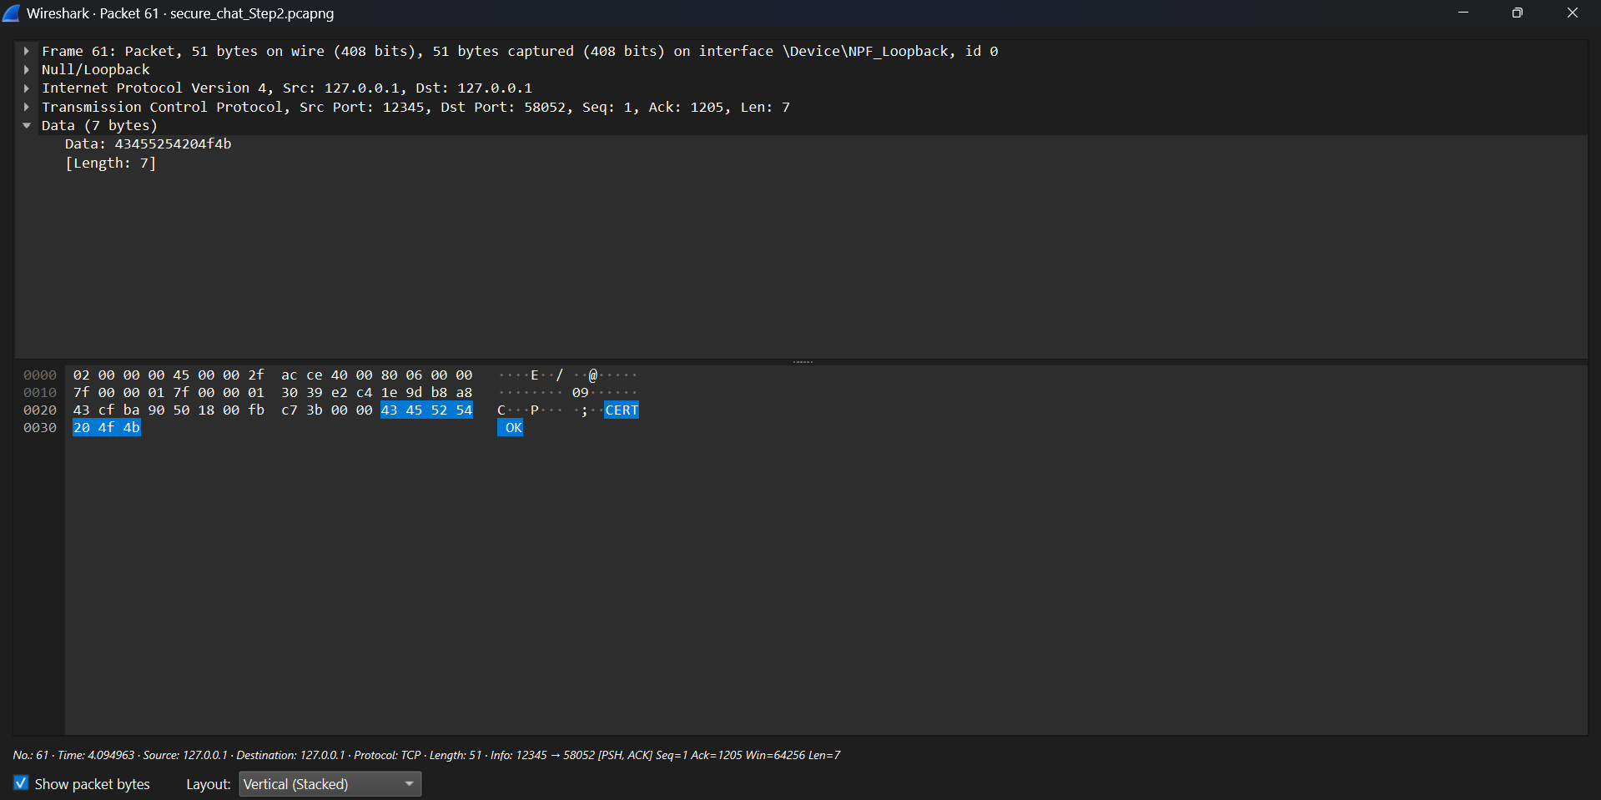

Login Payload:

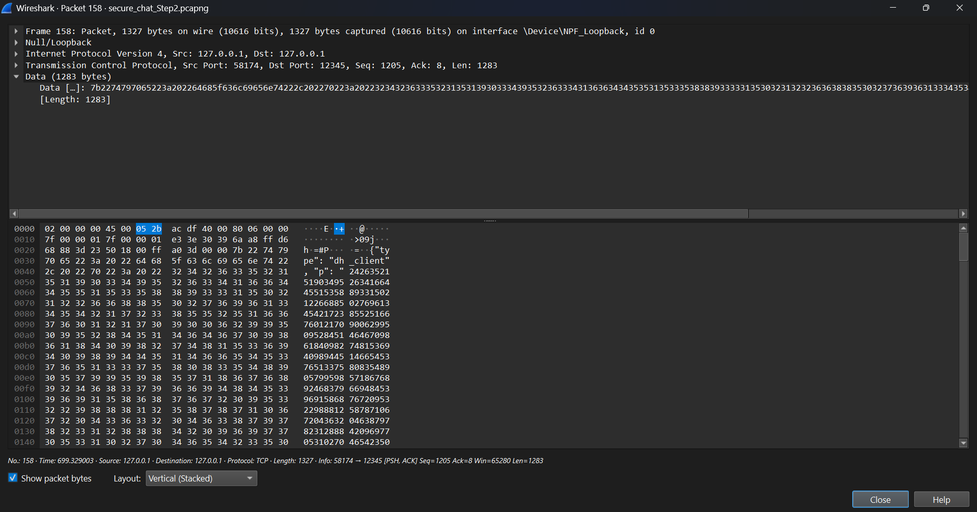

Login response:

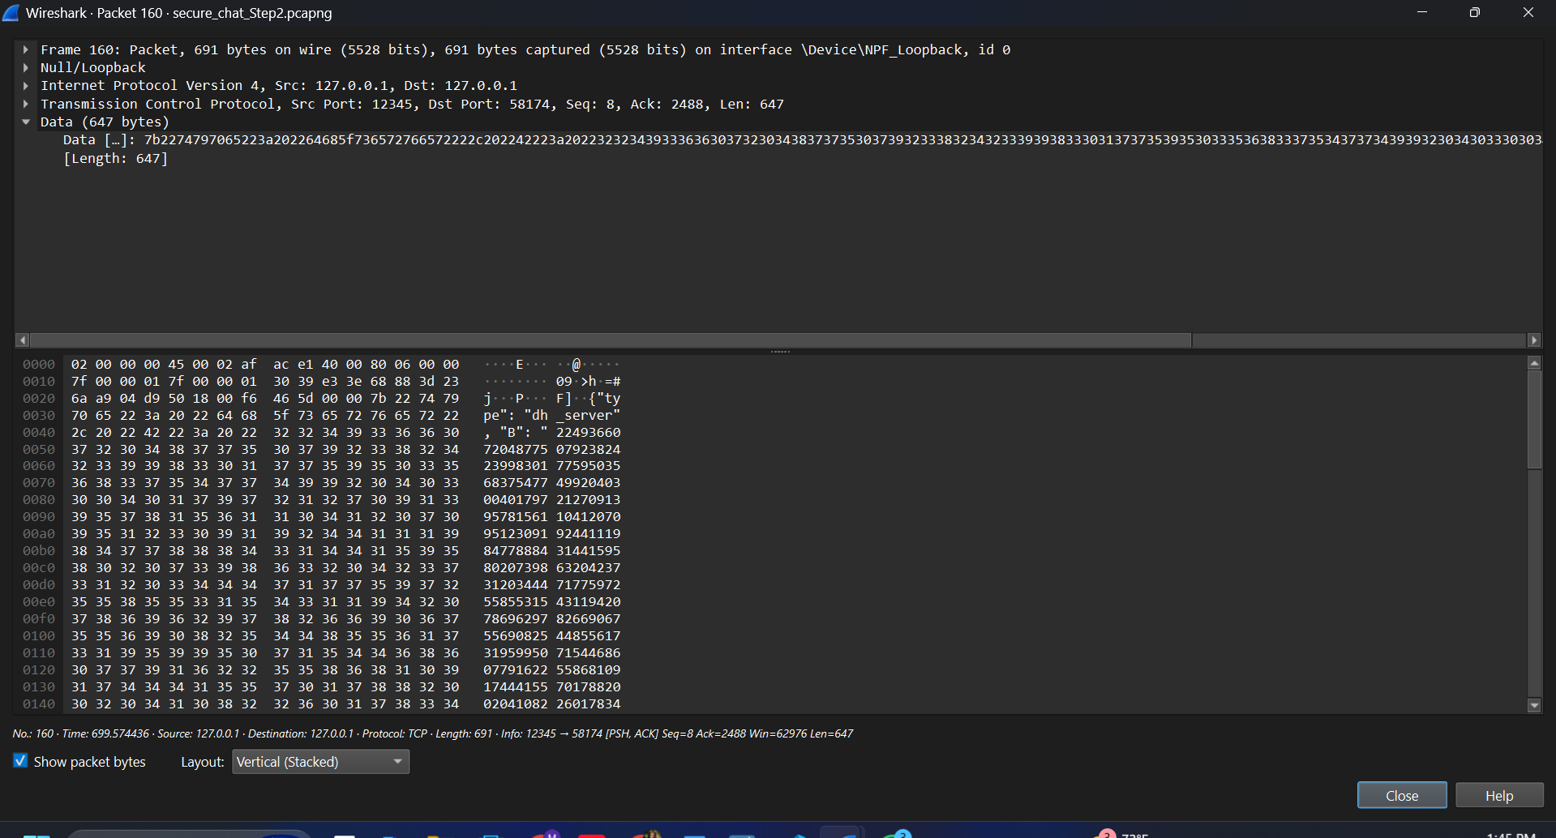

Step 3: Session Key Establishment (Basic Diffie–Hellman):

Client_Certificate_Exchange:

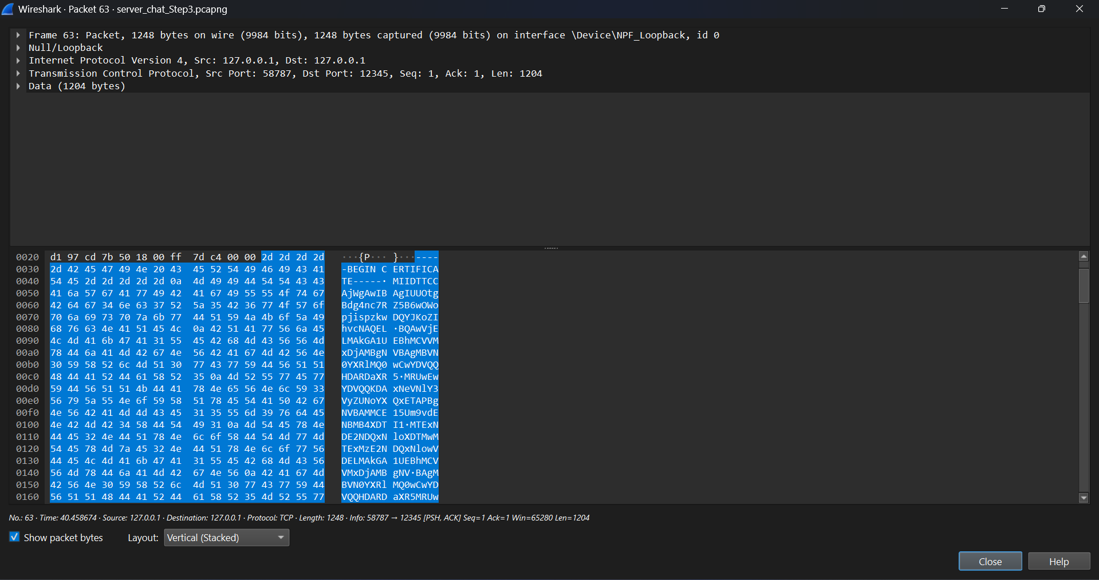

Server Certificate Validation / ACK:

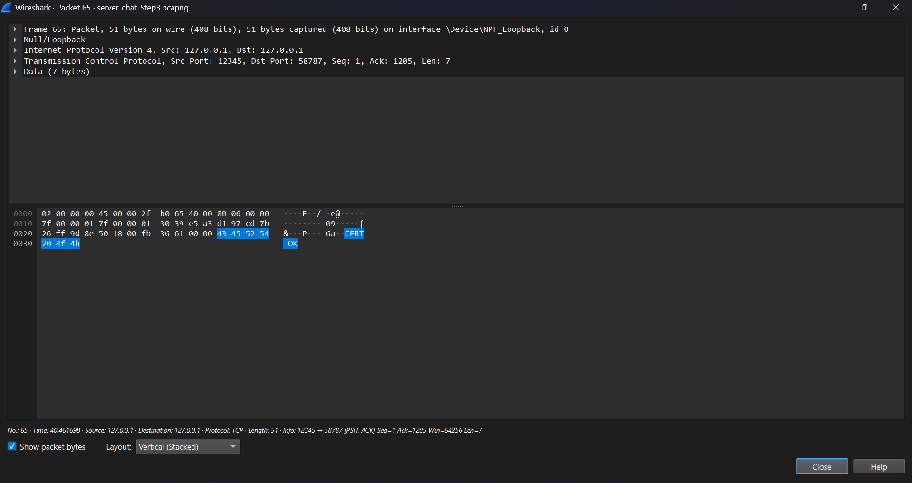

Diffie–Hellman Key Exchange:

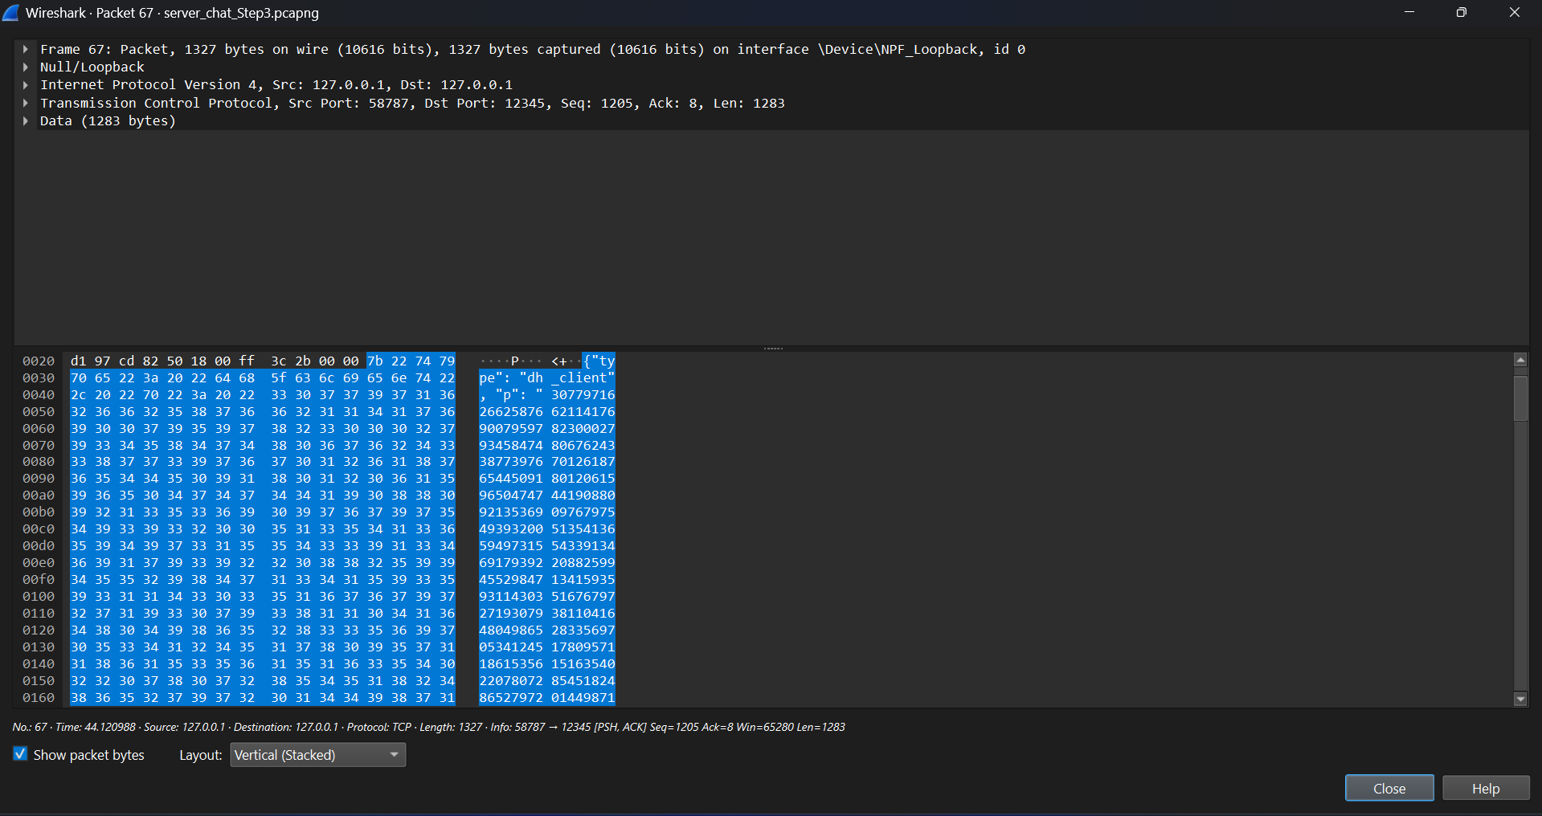

Encrypted Registration Payload:

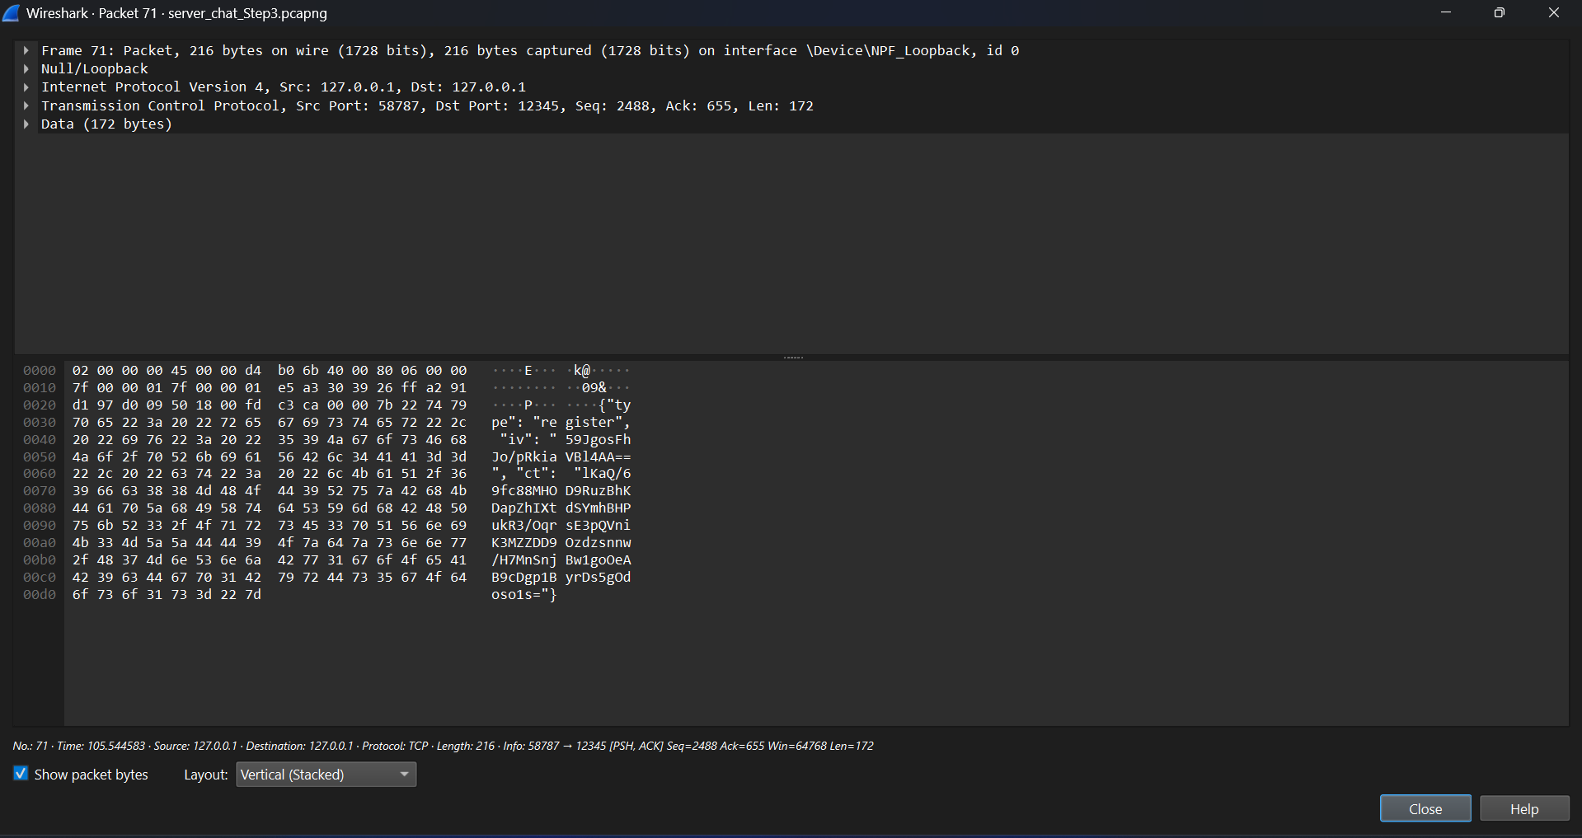  
  
Server Response to Registration:

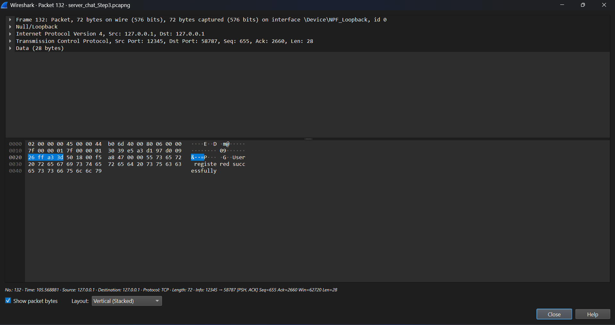  
  
Encrypted Login Payload:

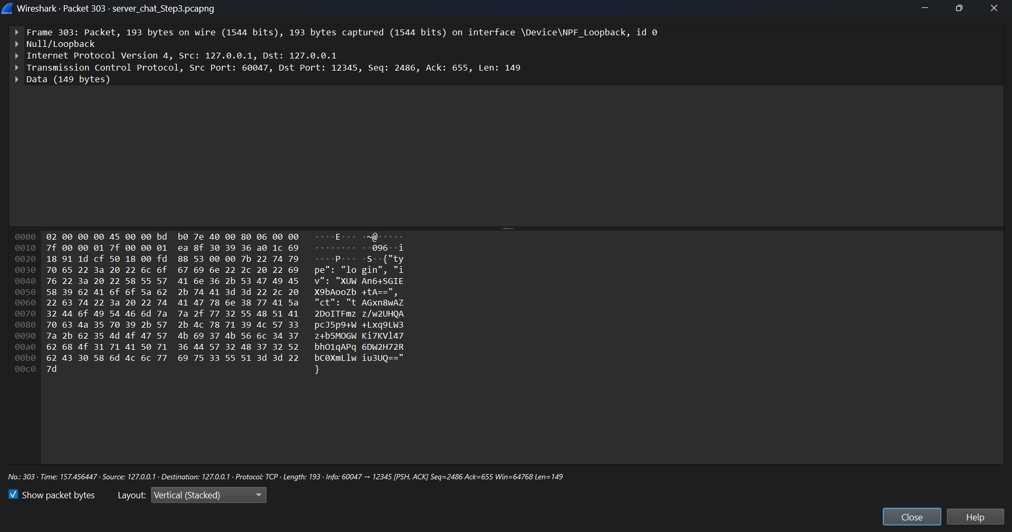  
  
Server Response to Login:

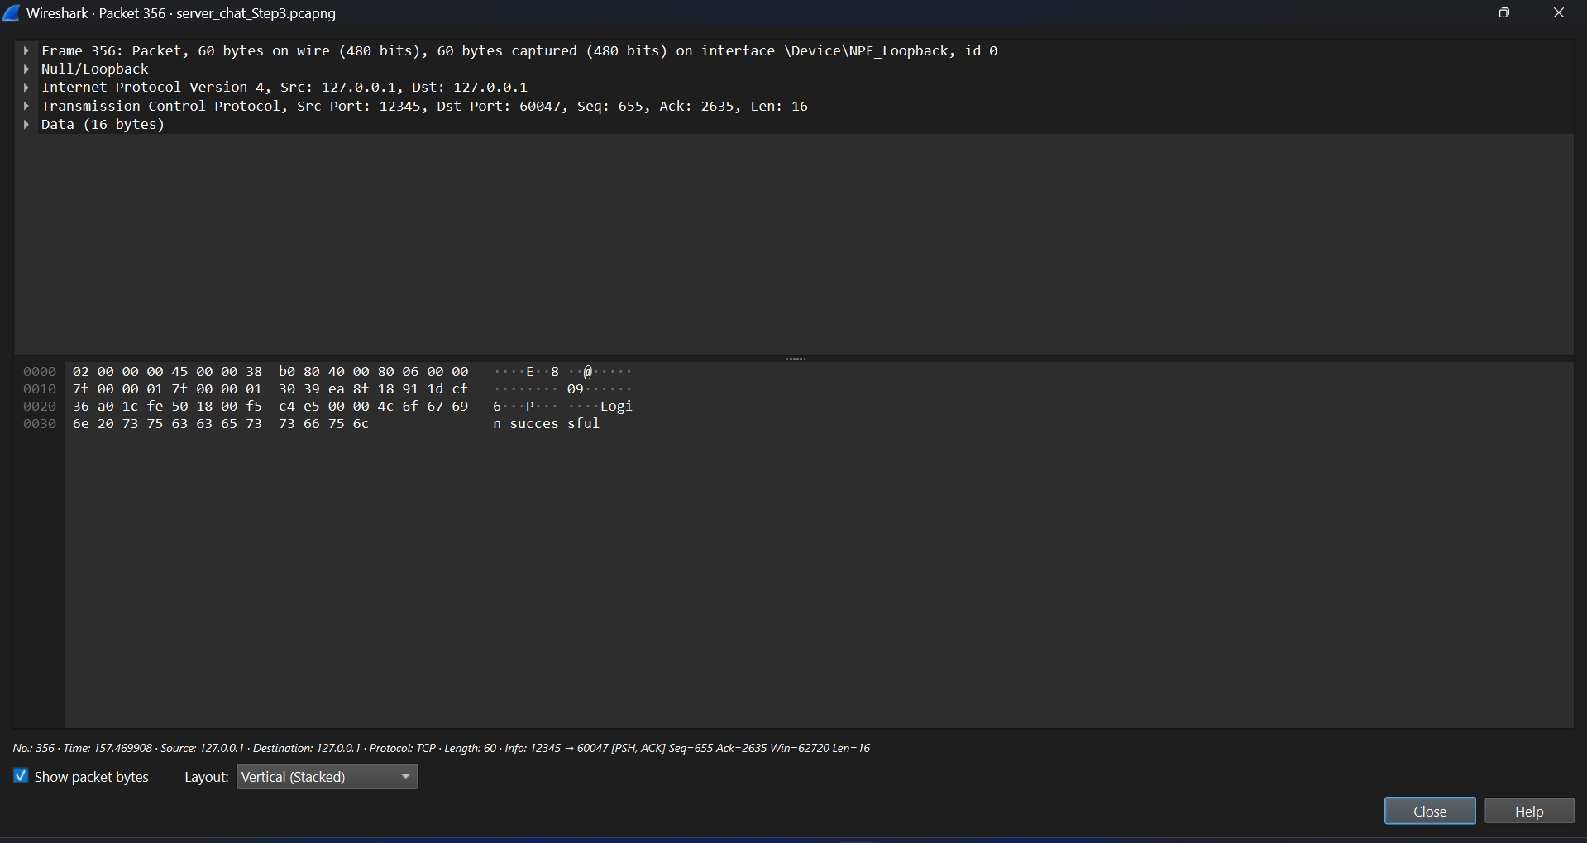  
  
Session key derived or created:

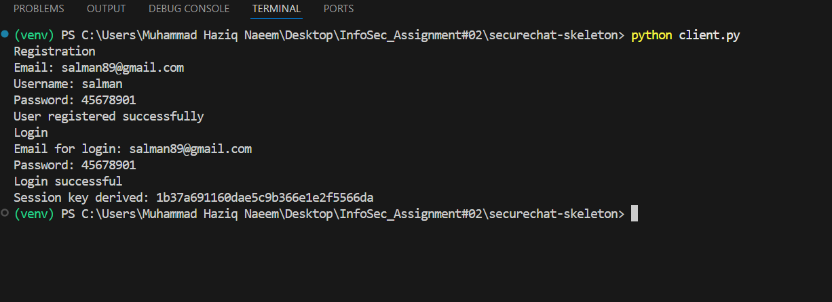

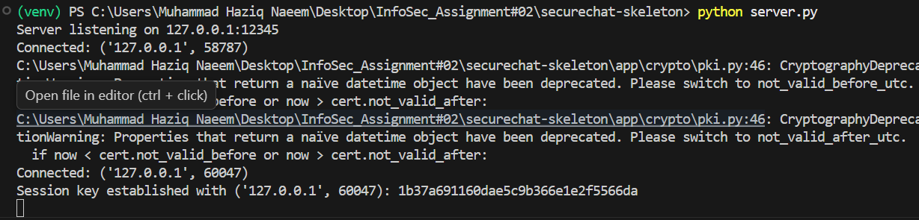

Step 4: Encrypted Chat and Message Integrity:

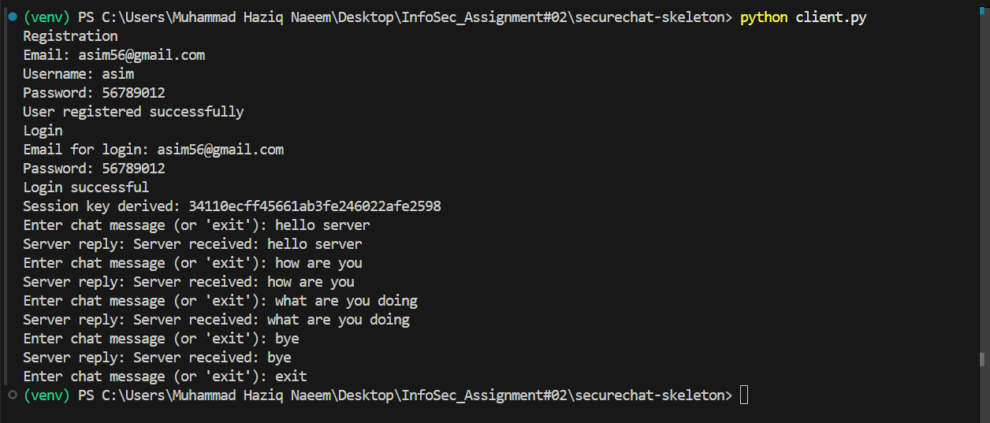

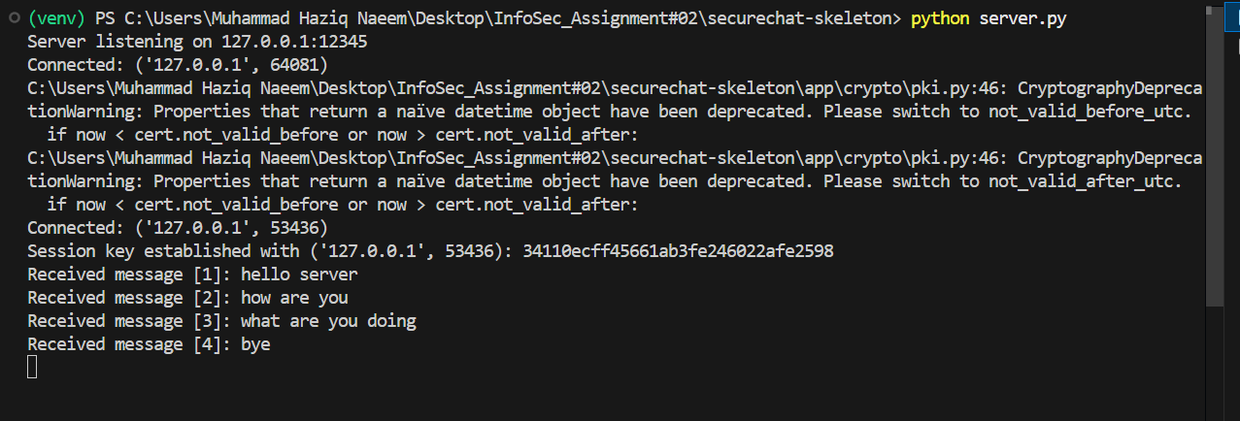

TCP_Handshake:

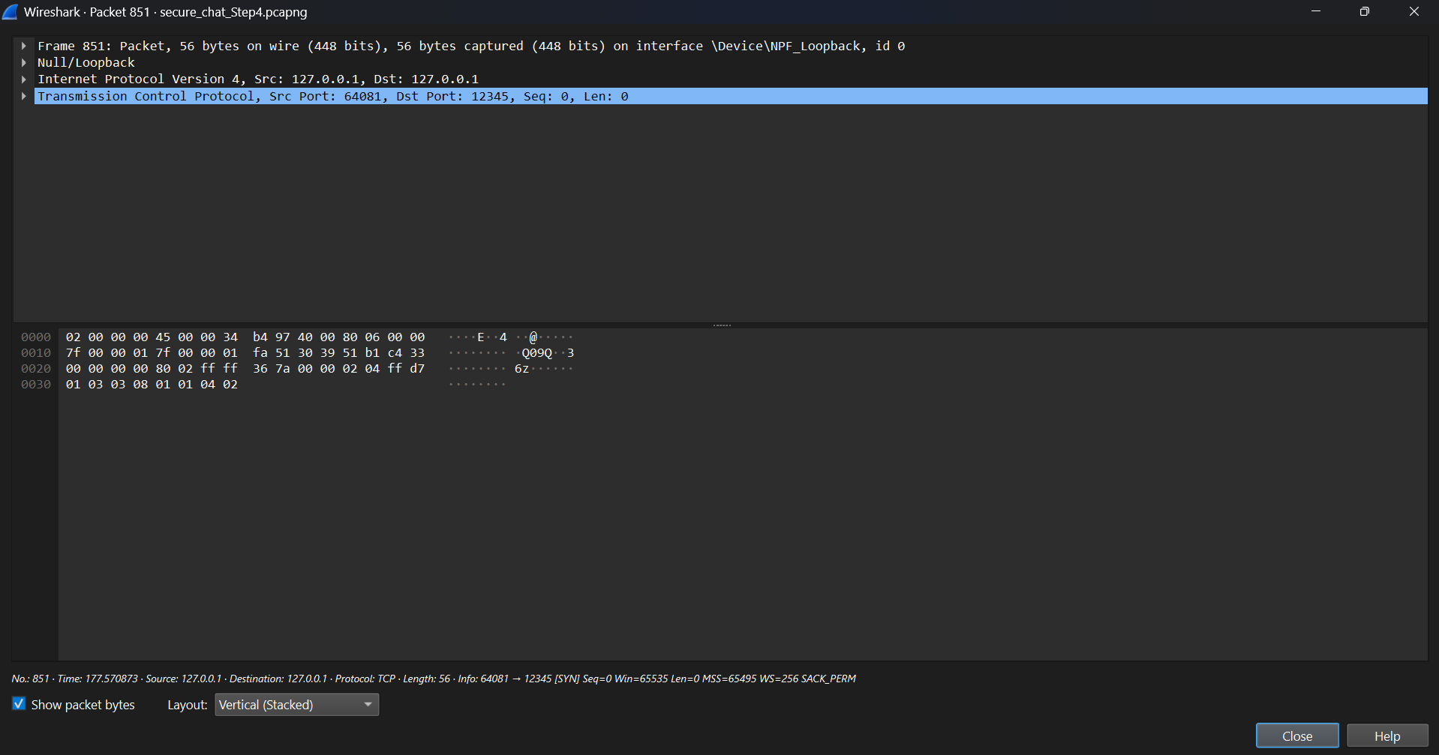

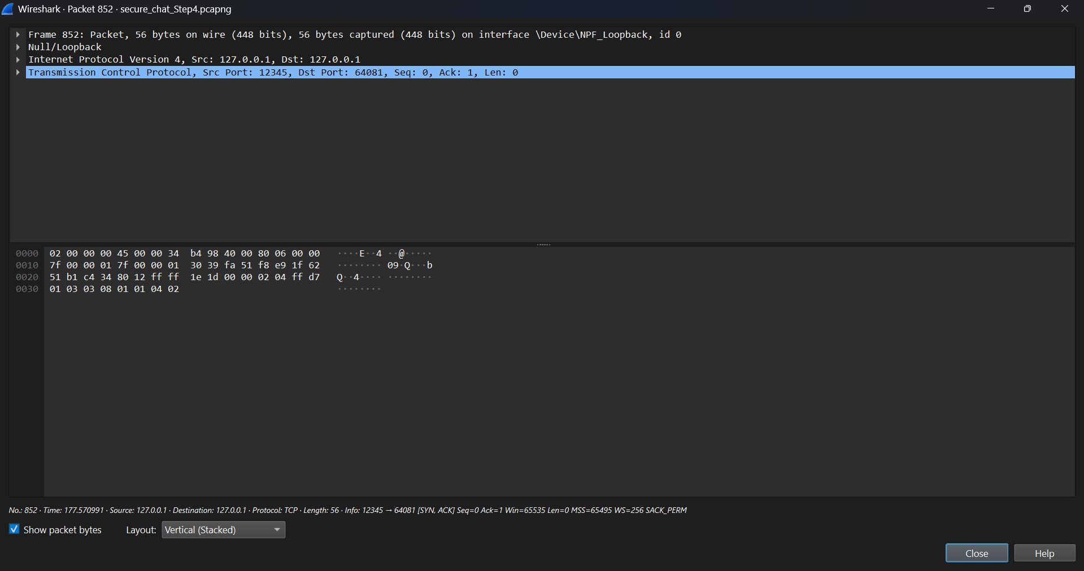

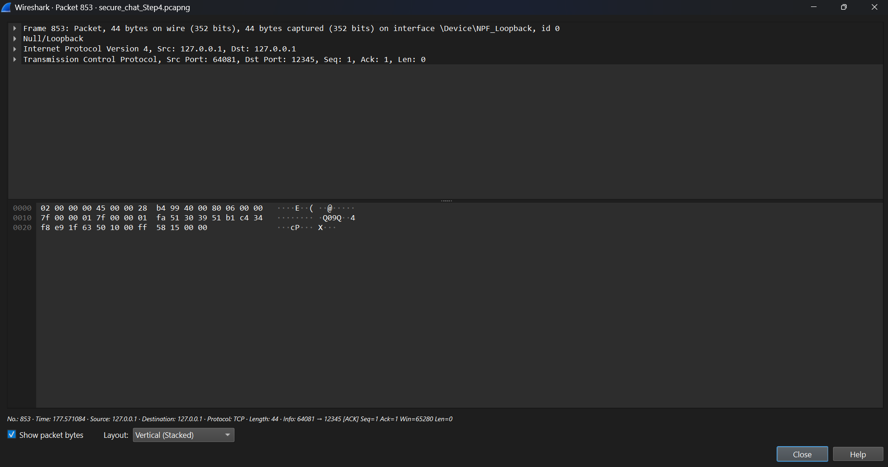

Certificate_Exchange:

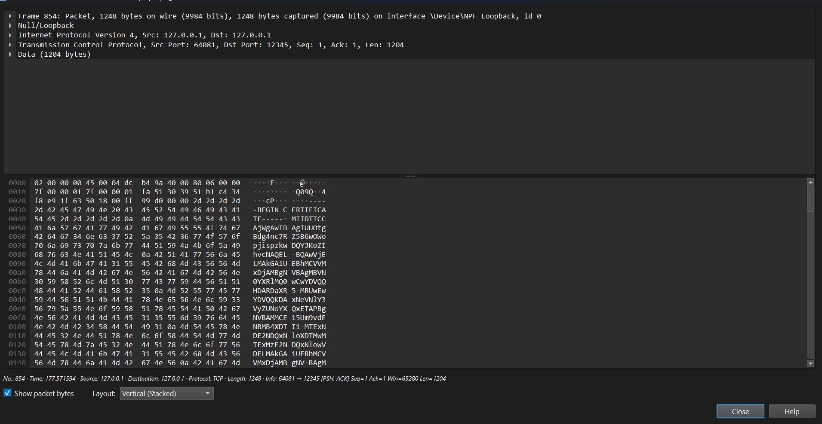

DH_Key_Exchange:

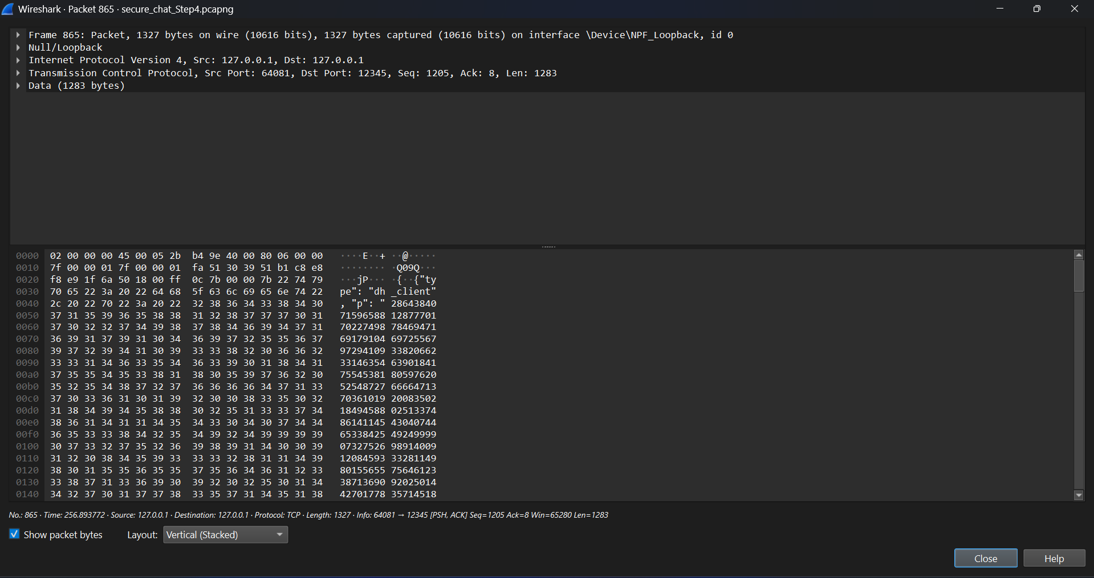

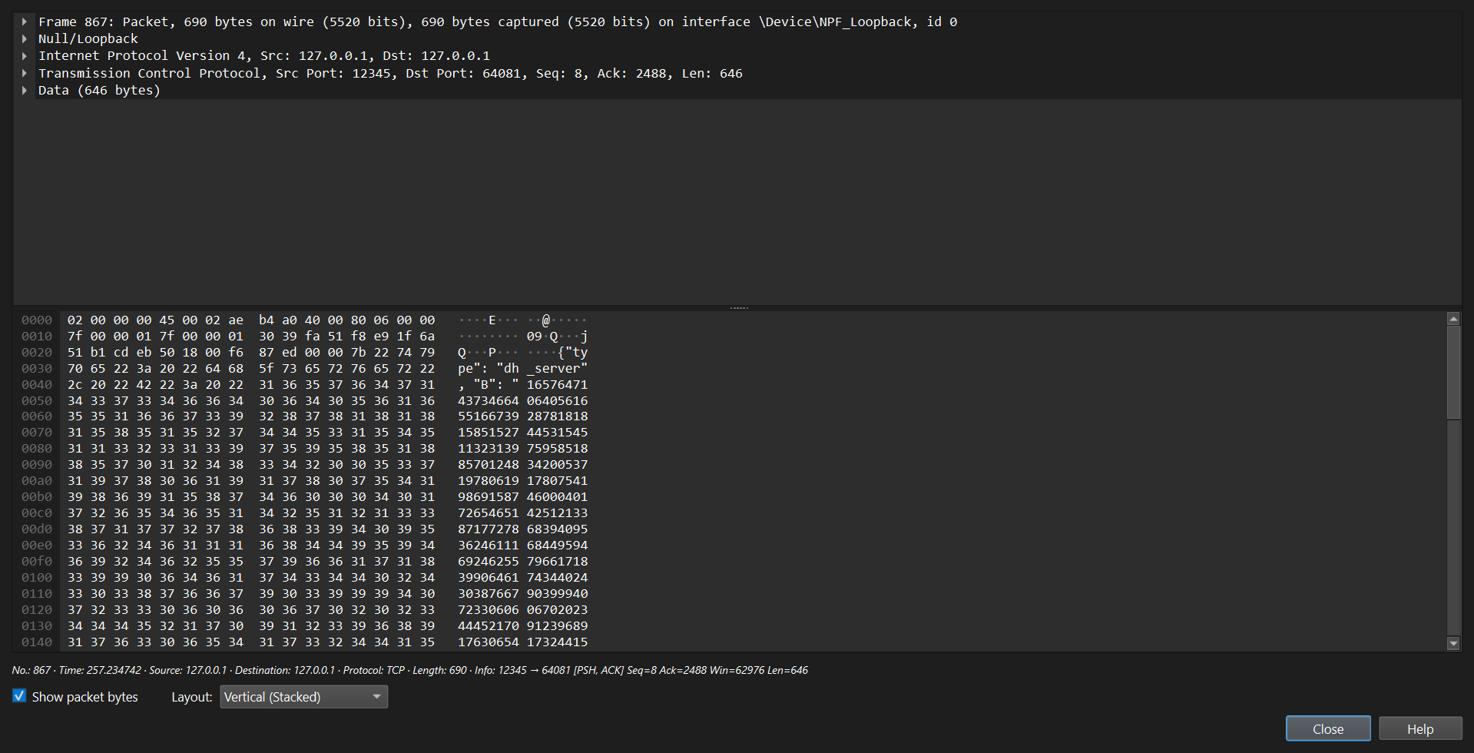

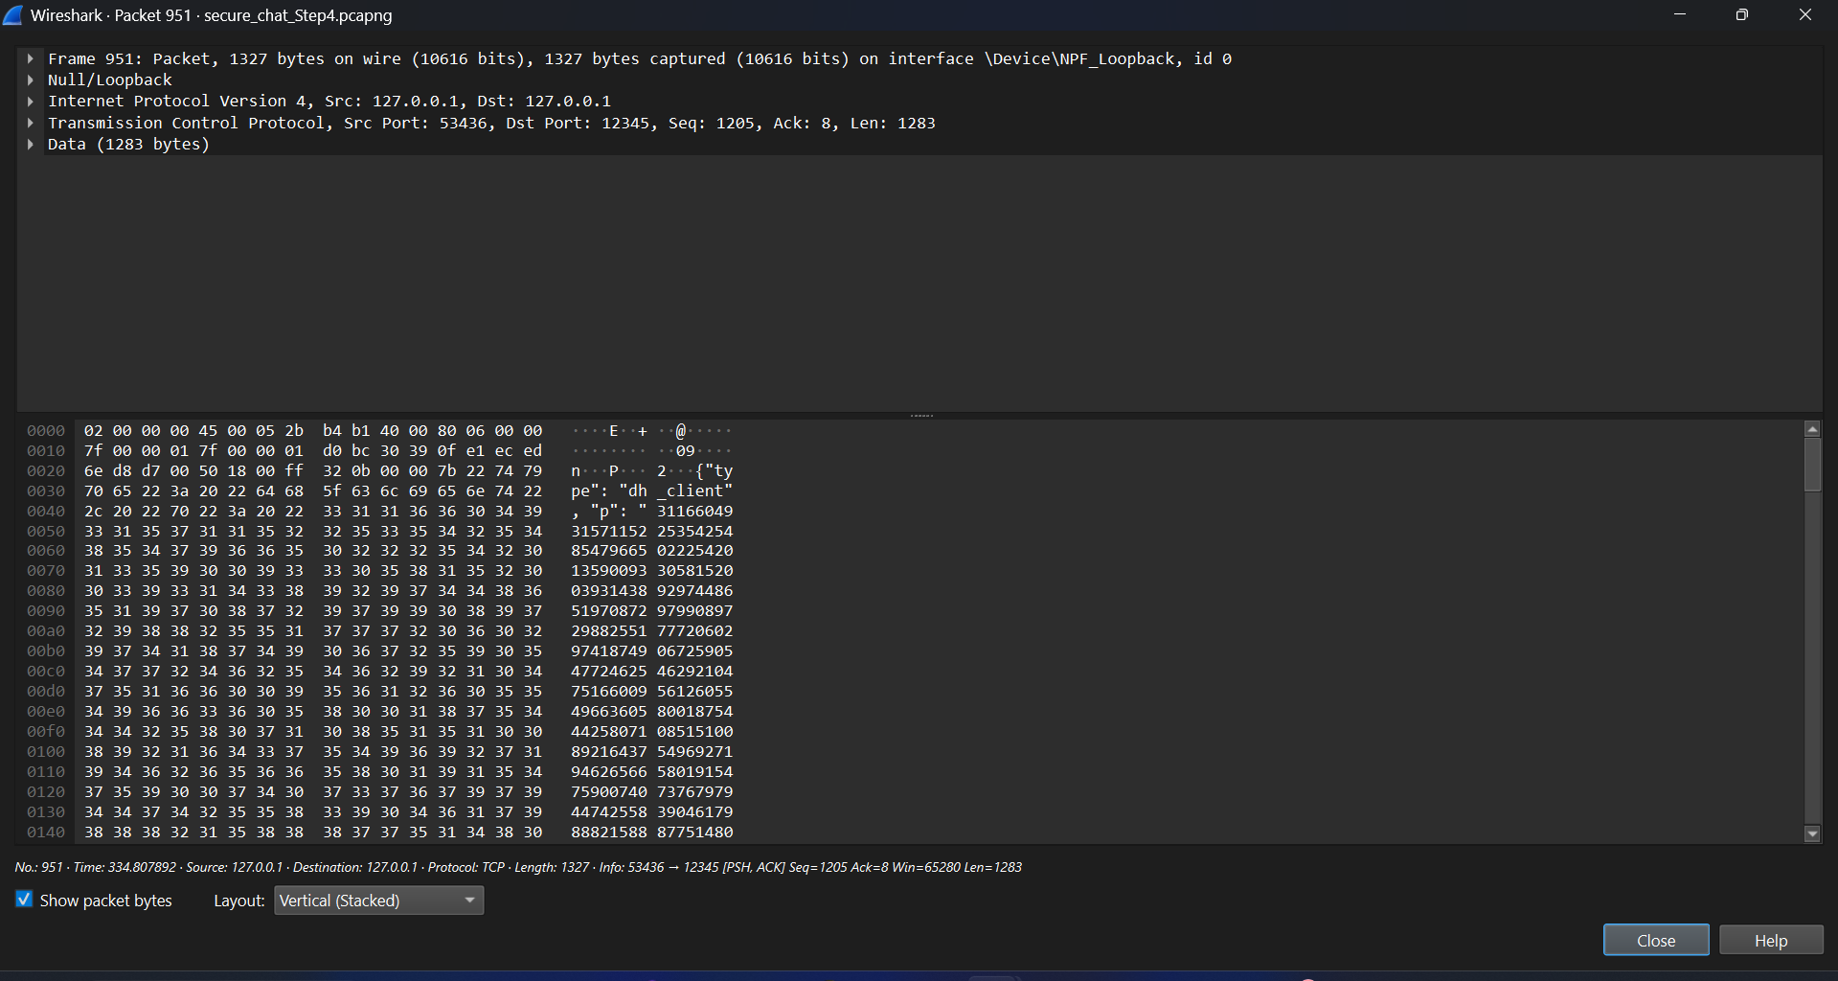

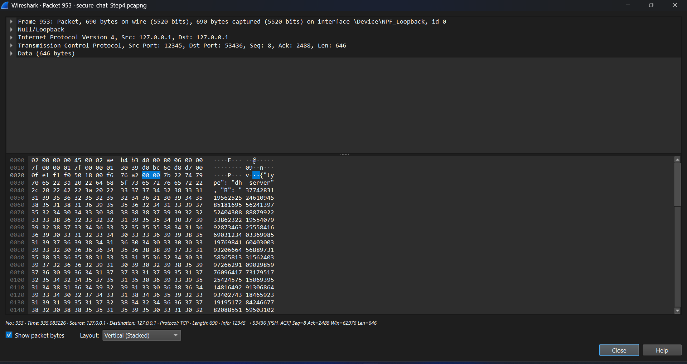

Encrypted_Login_Payload:

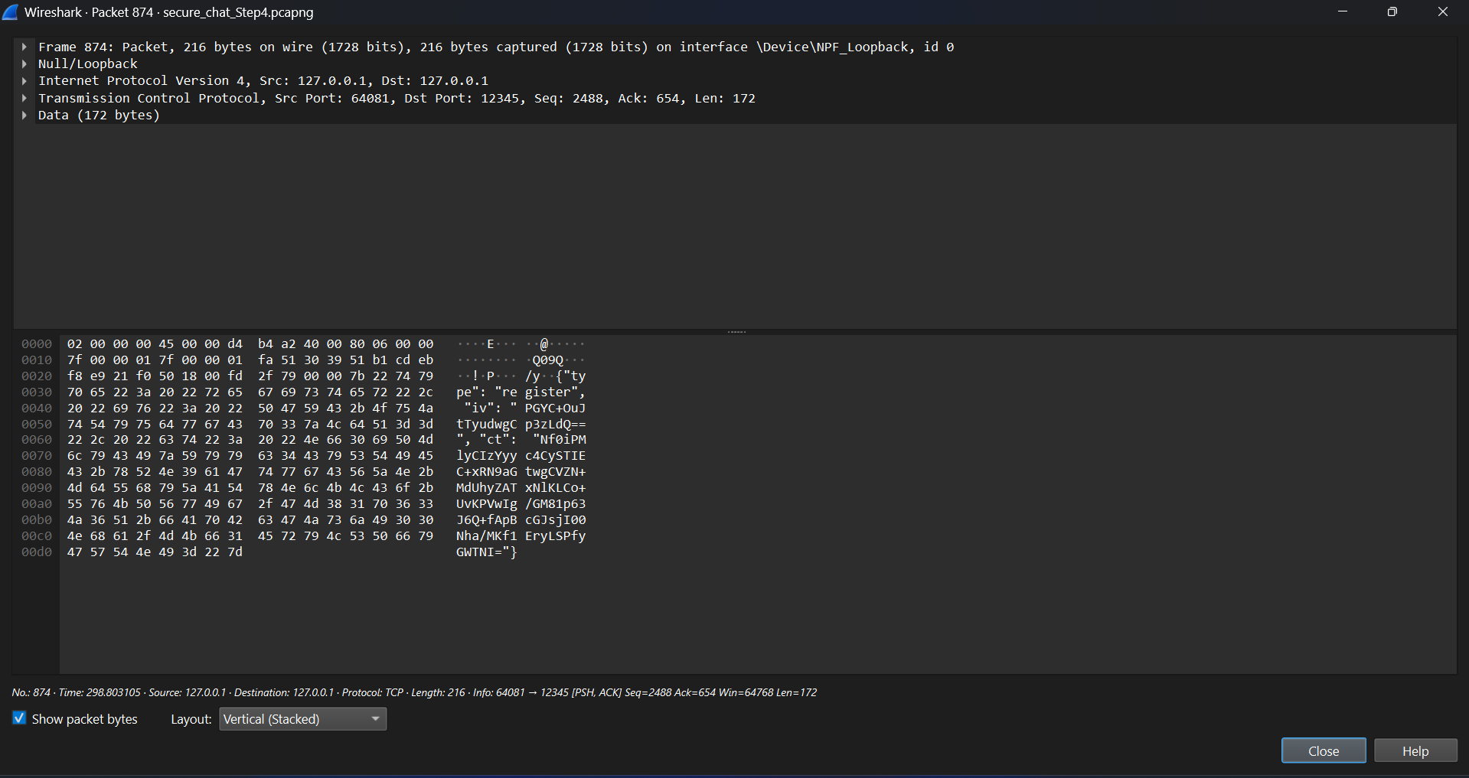

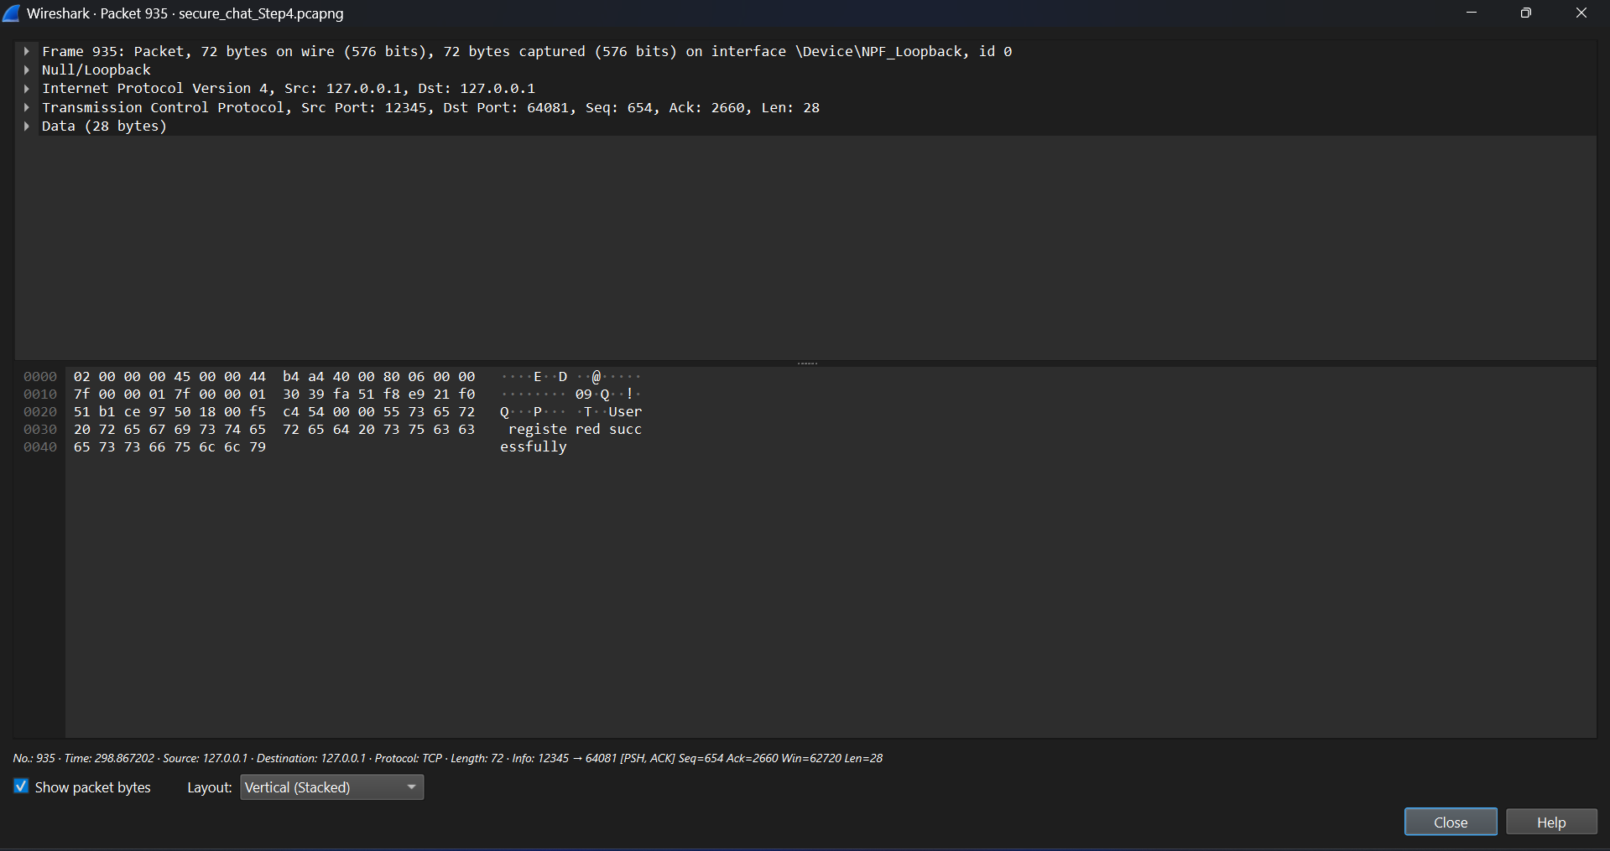

Encrypted_Chat_Messages:

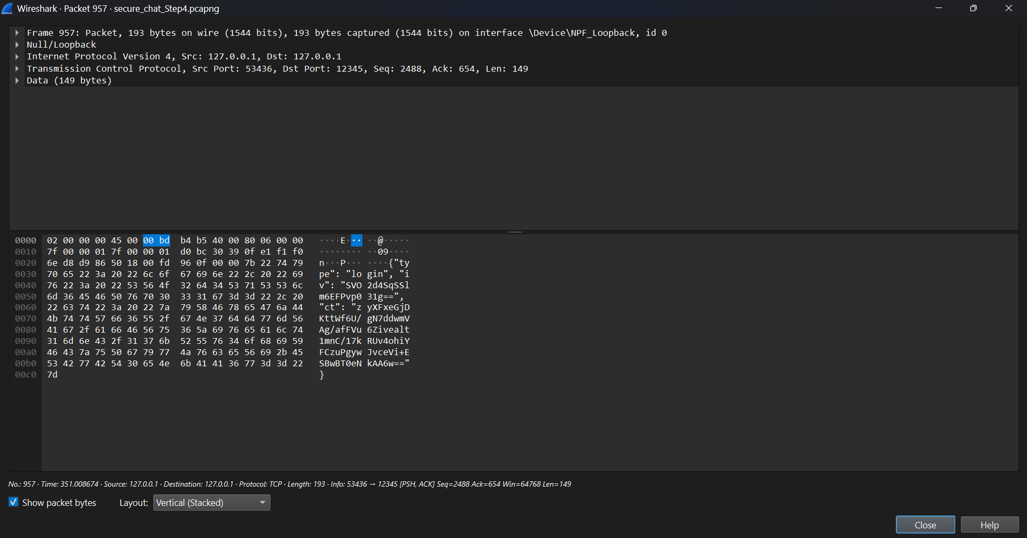

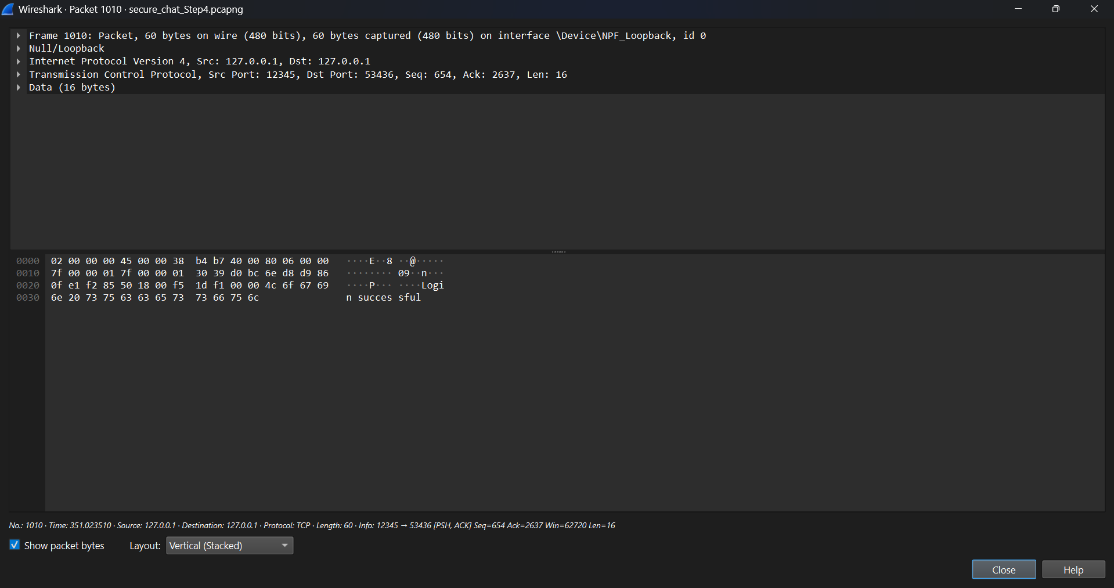

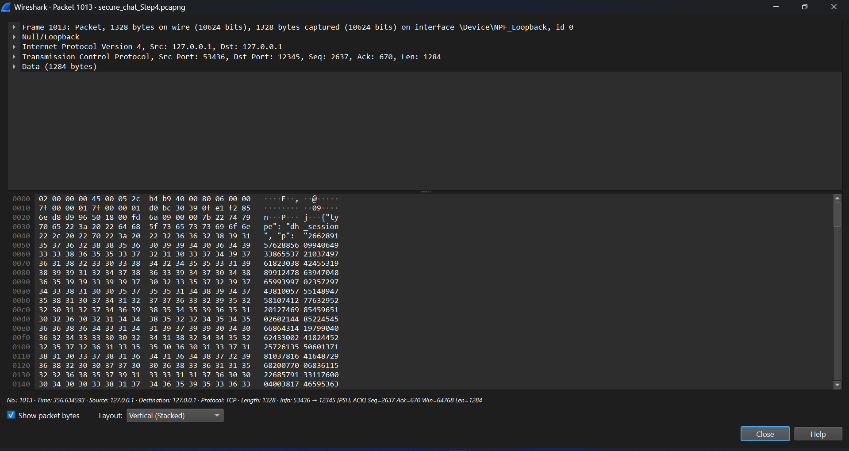

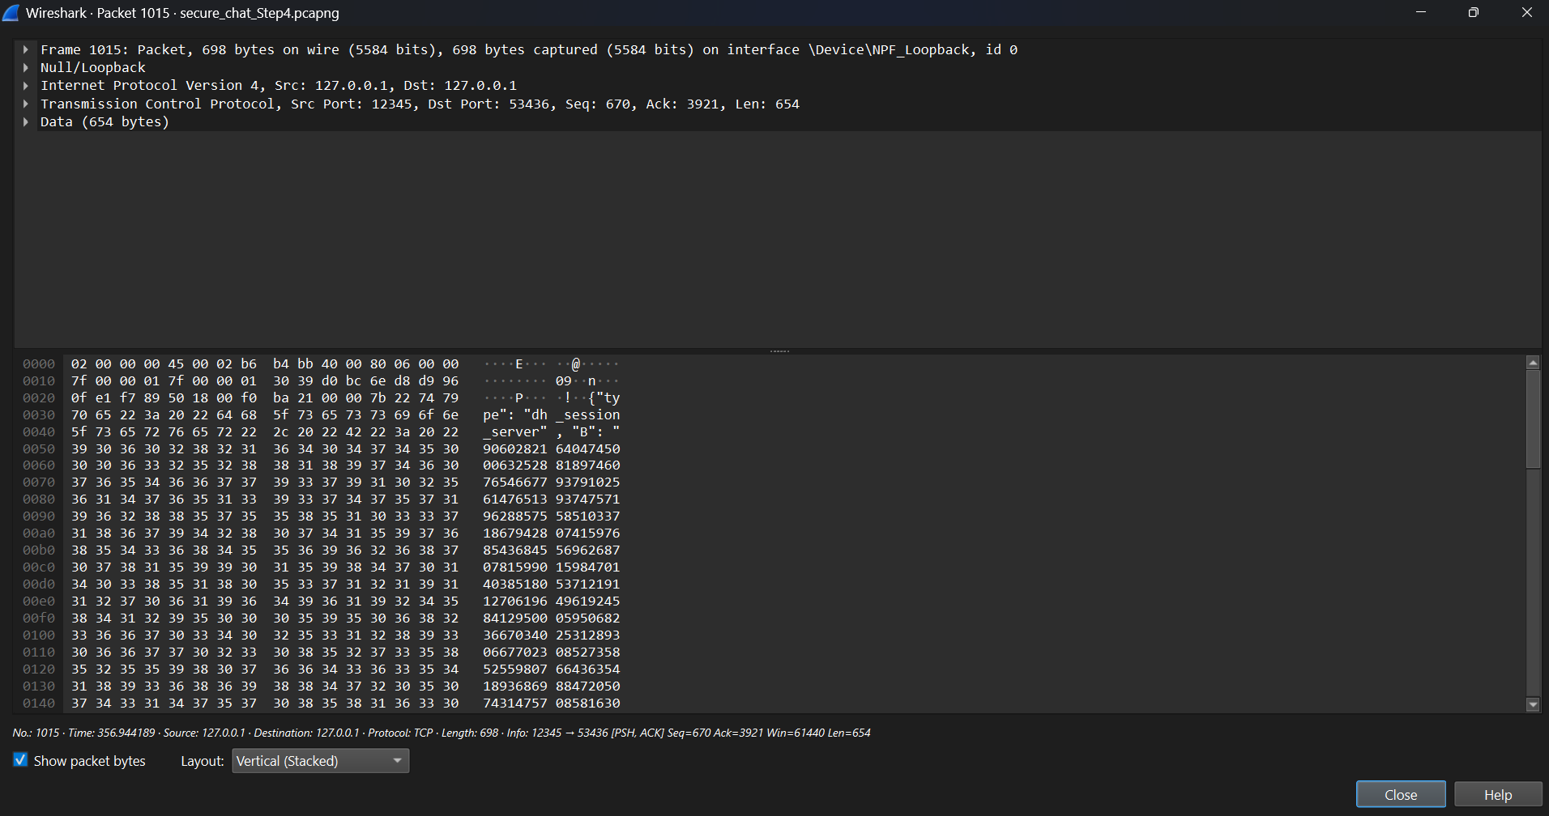

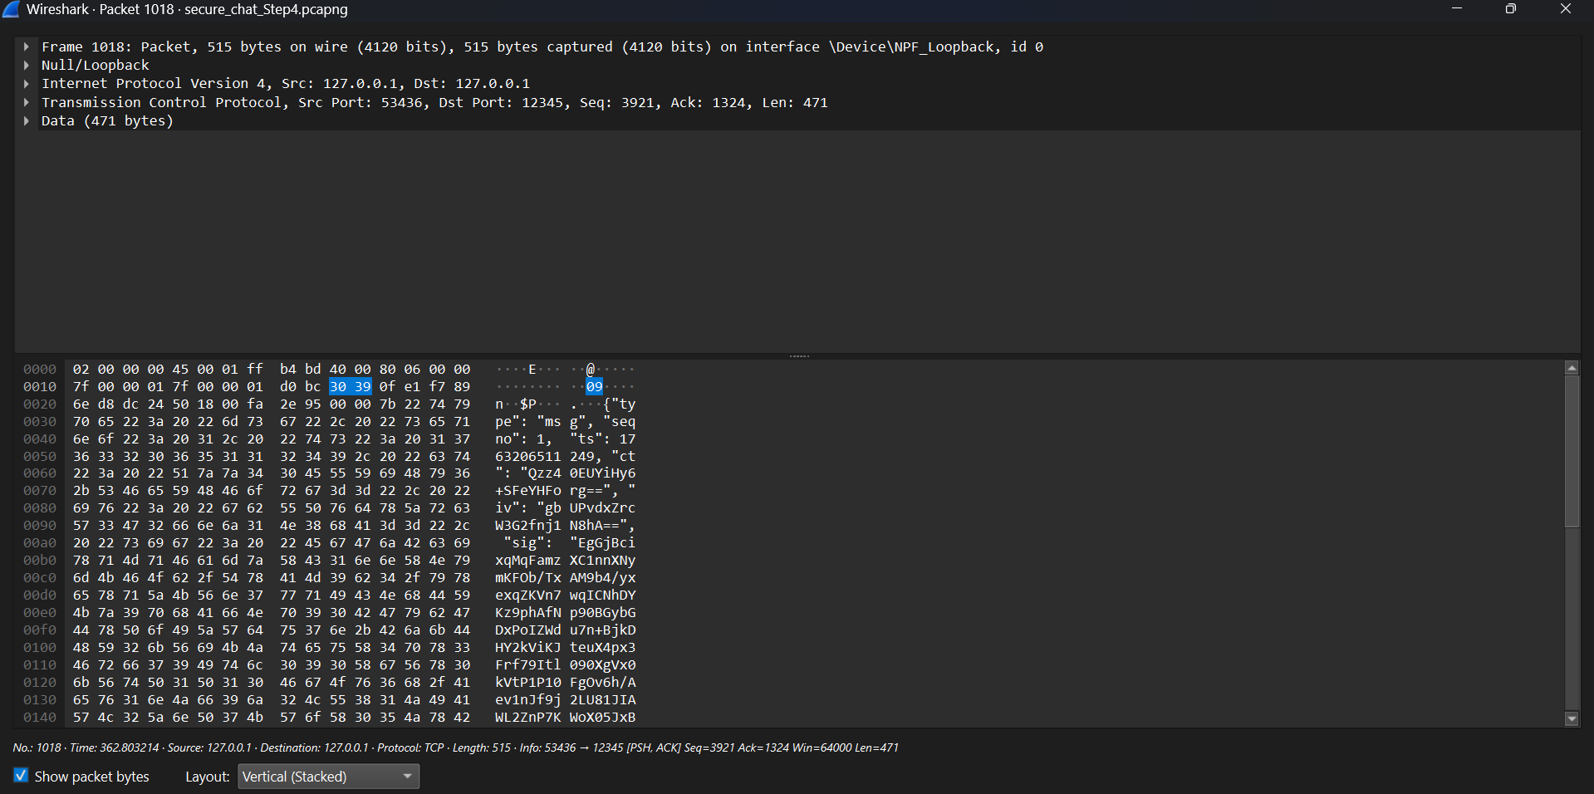

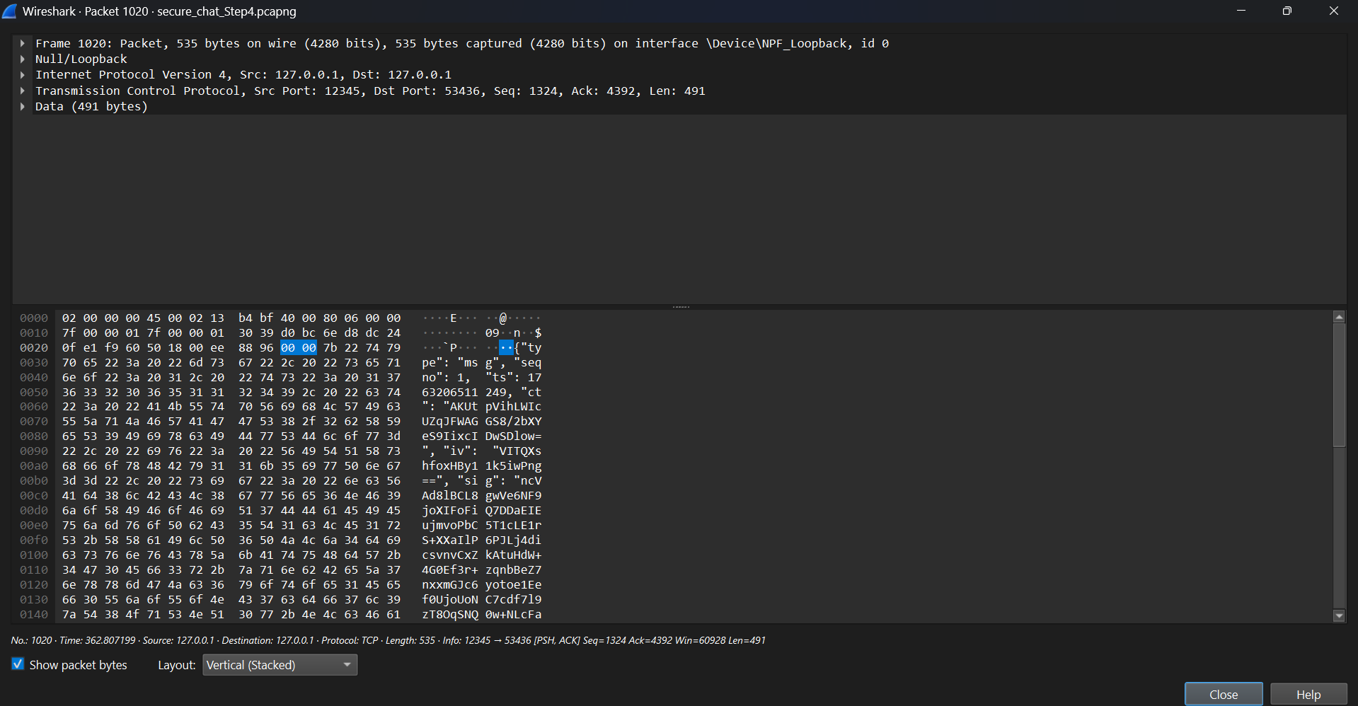

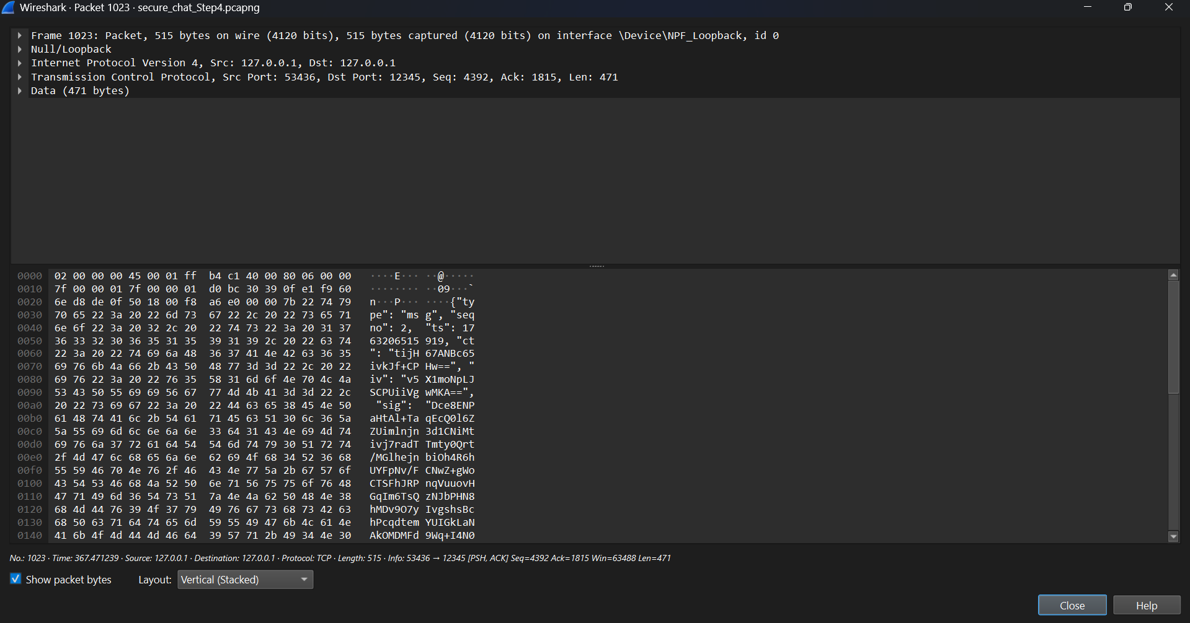

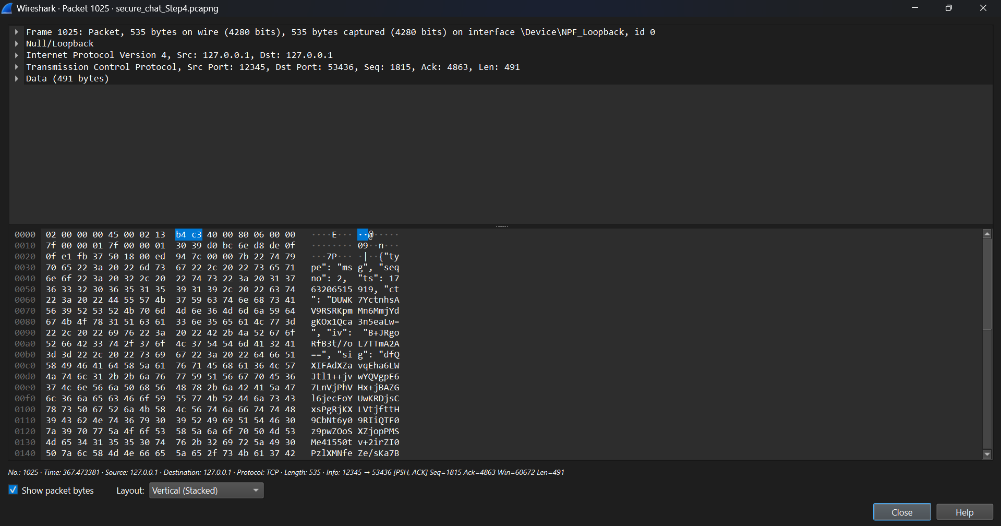

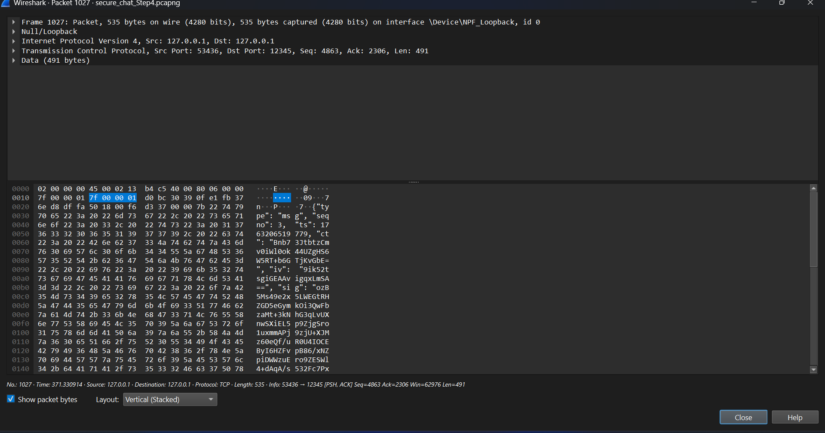

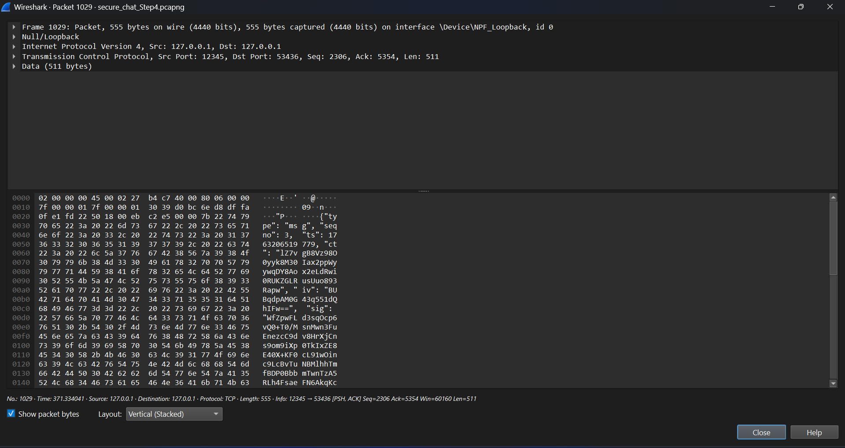

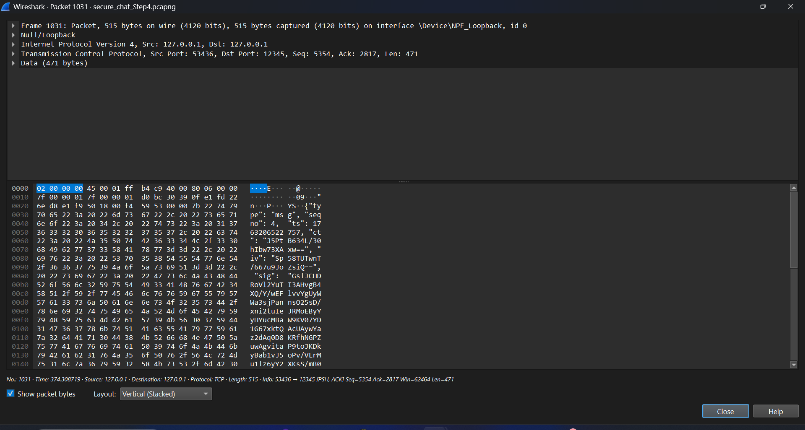

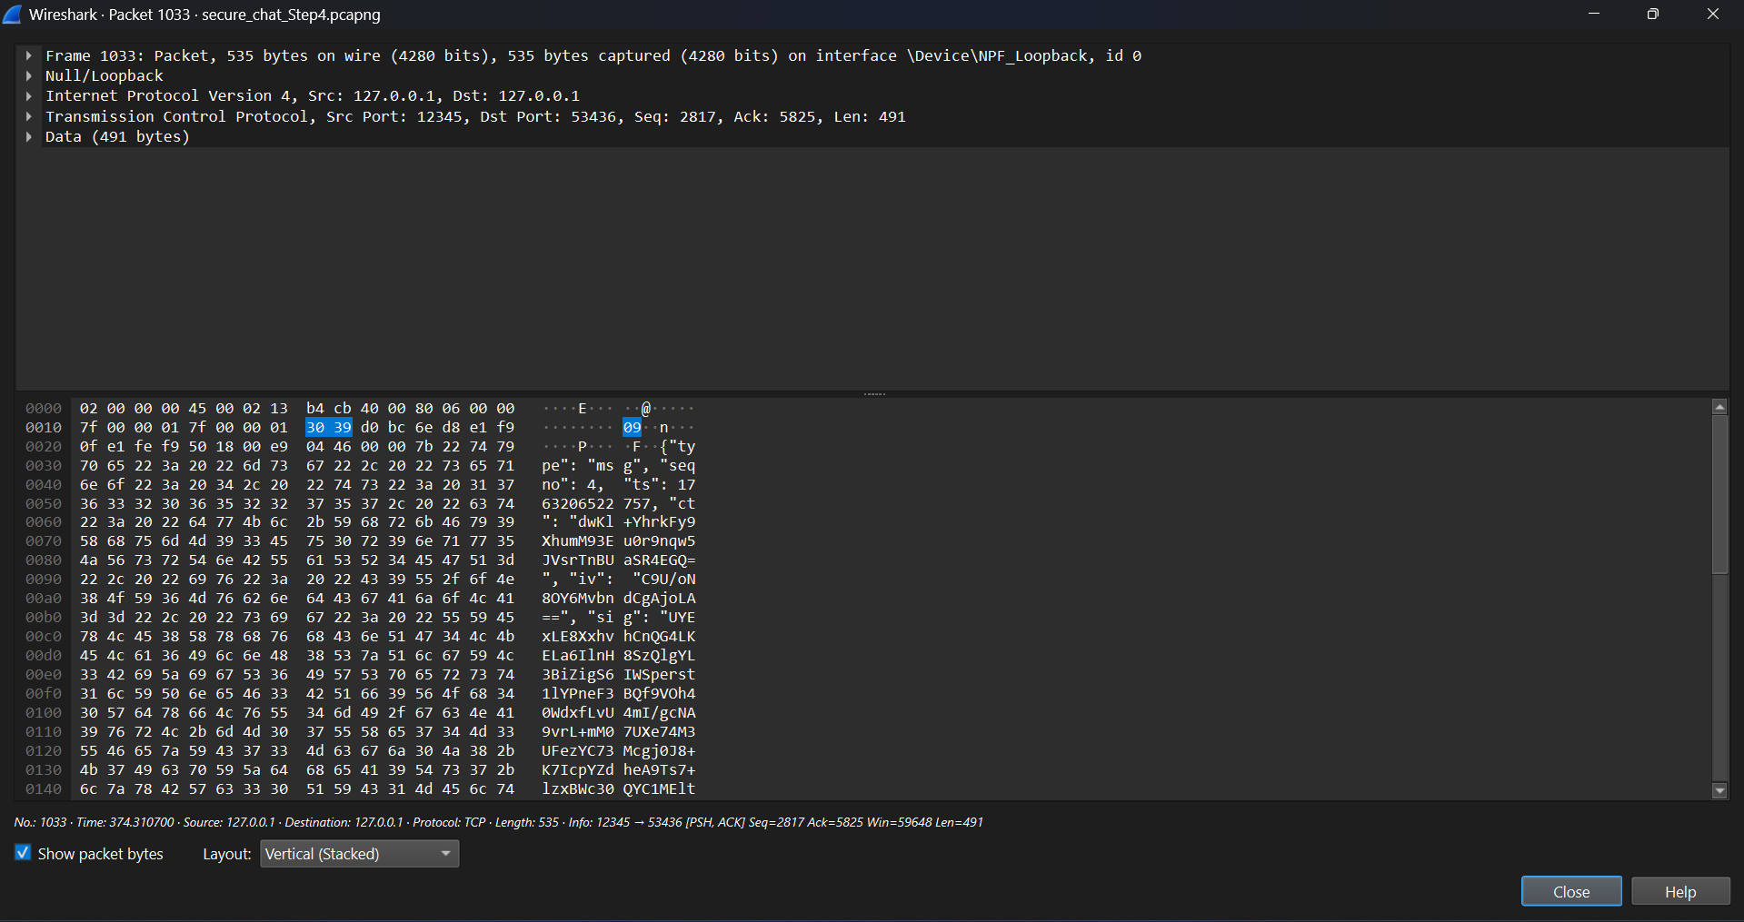

TCP_Connection_Termination:

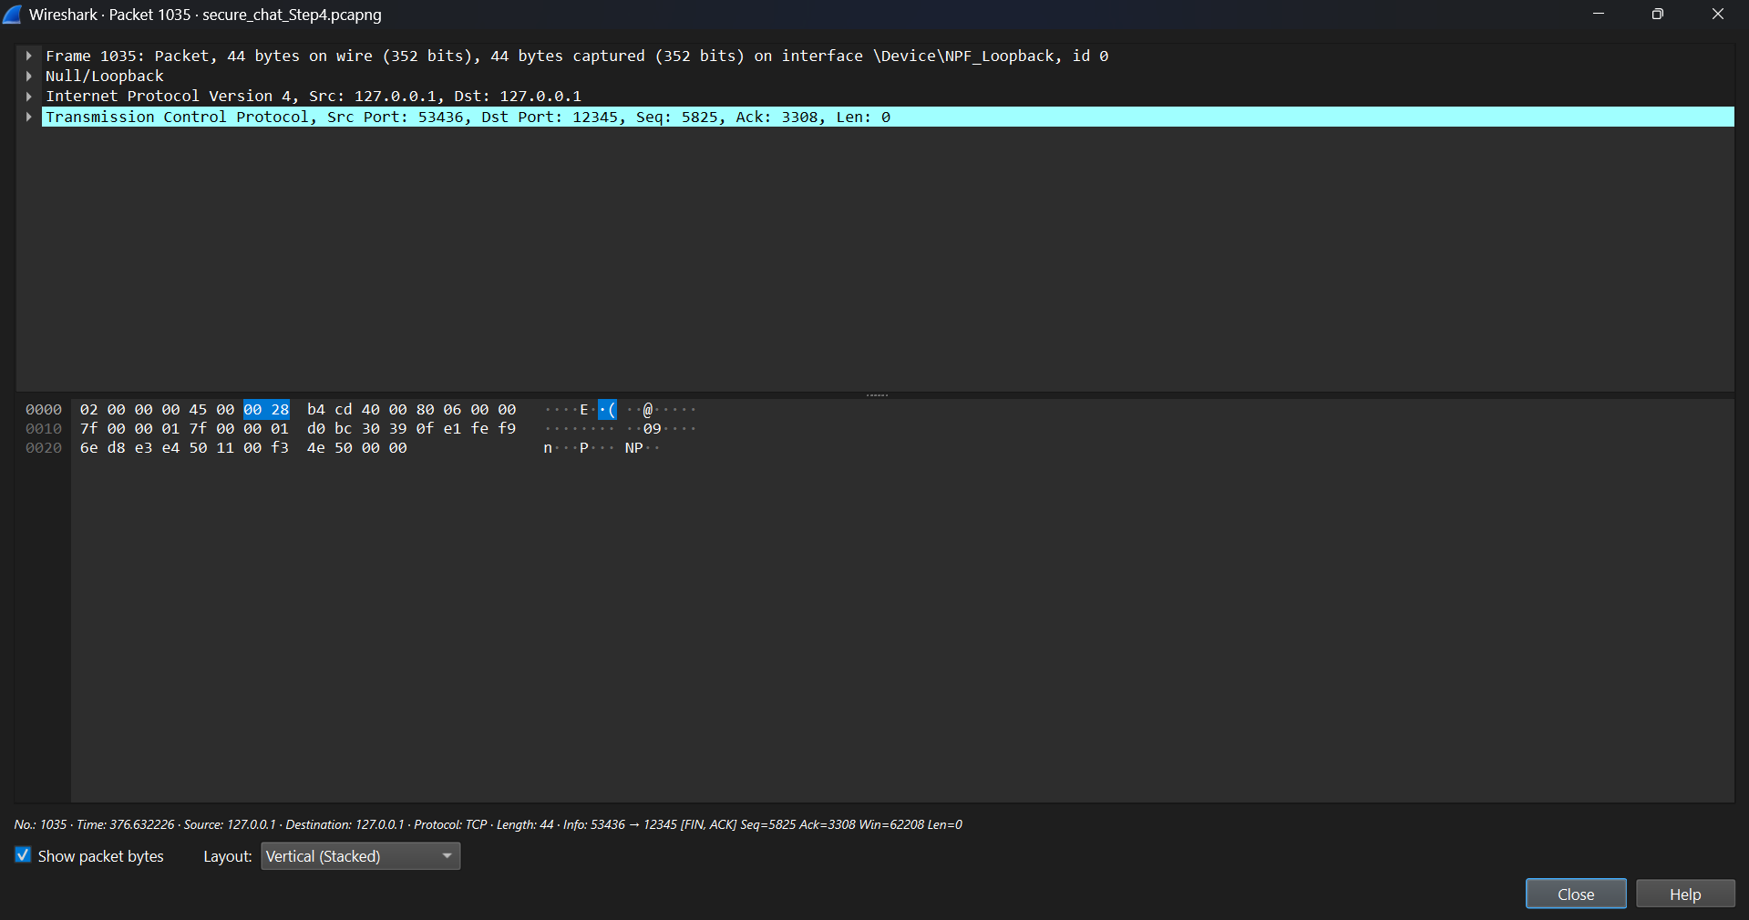

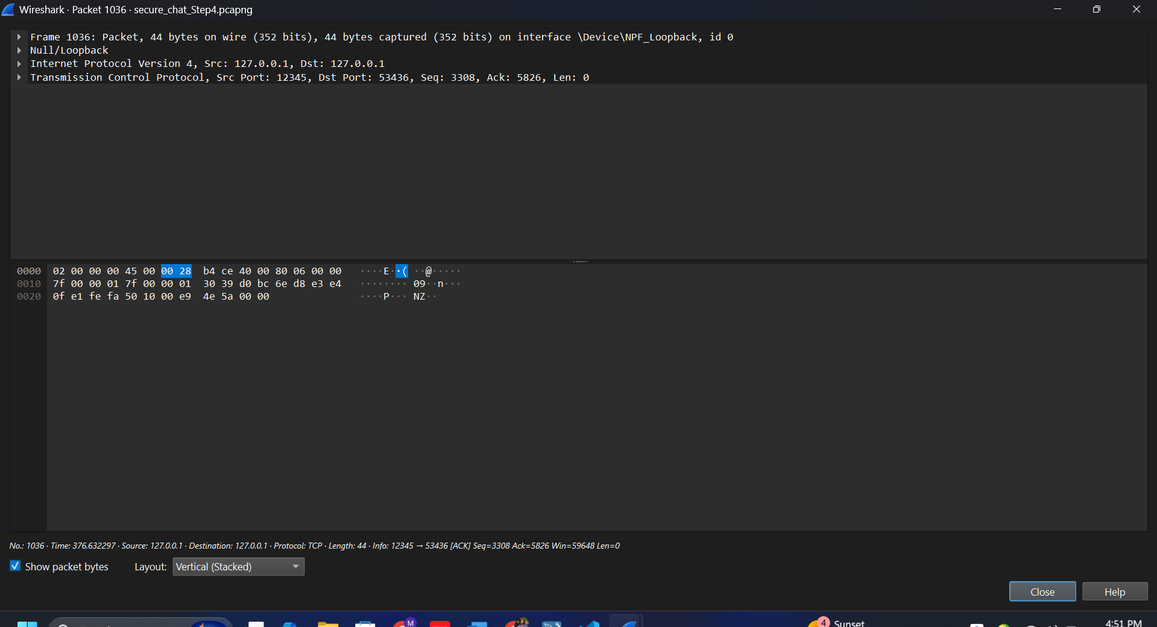

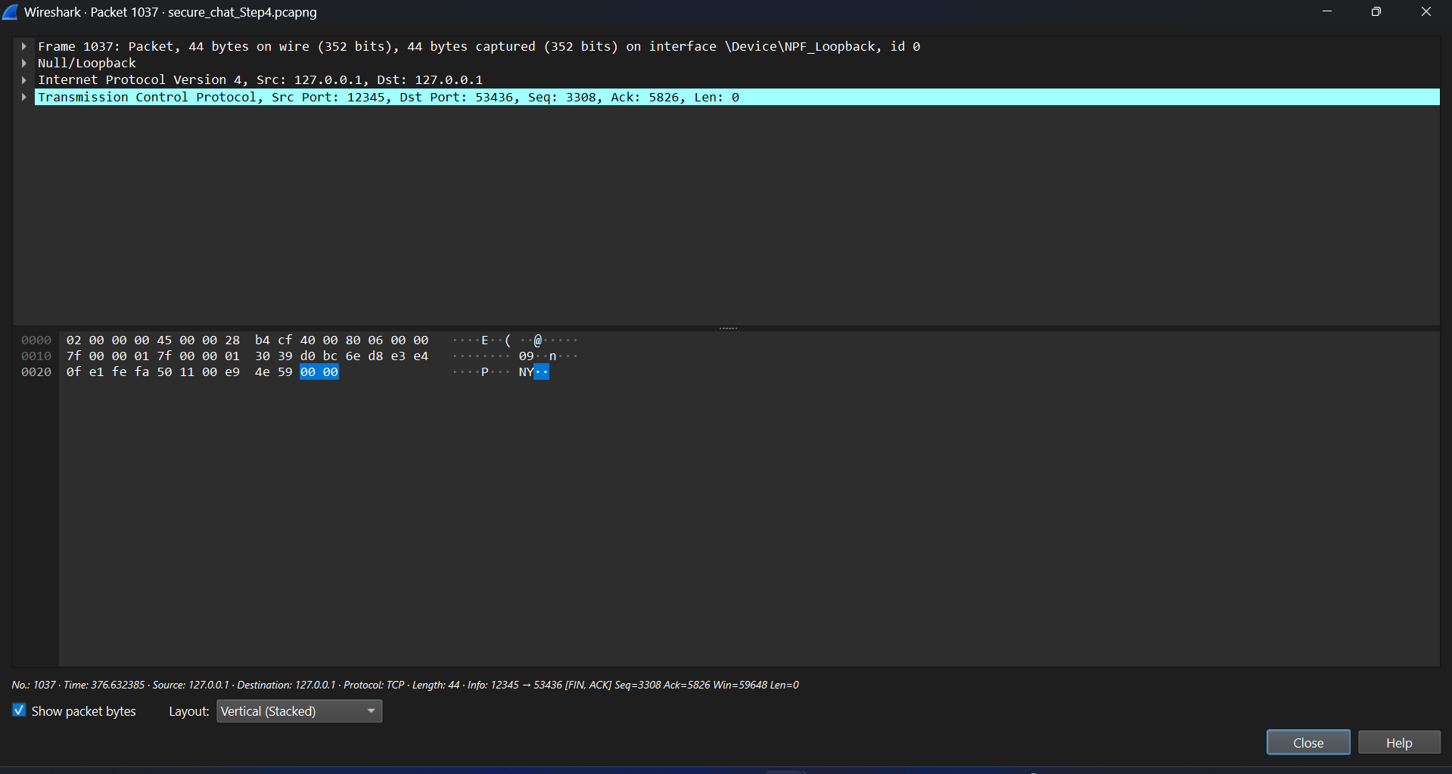

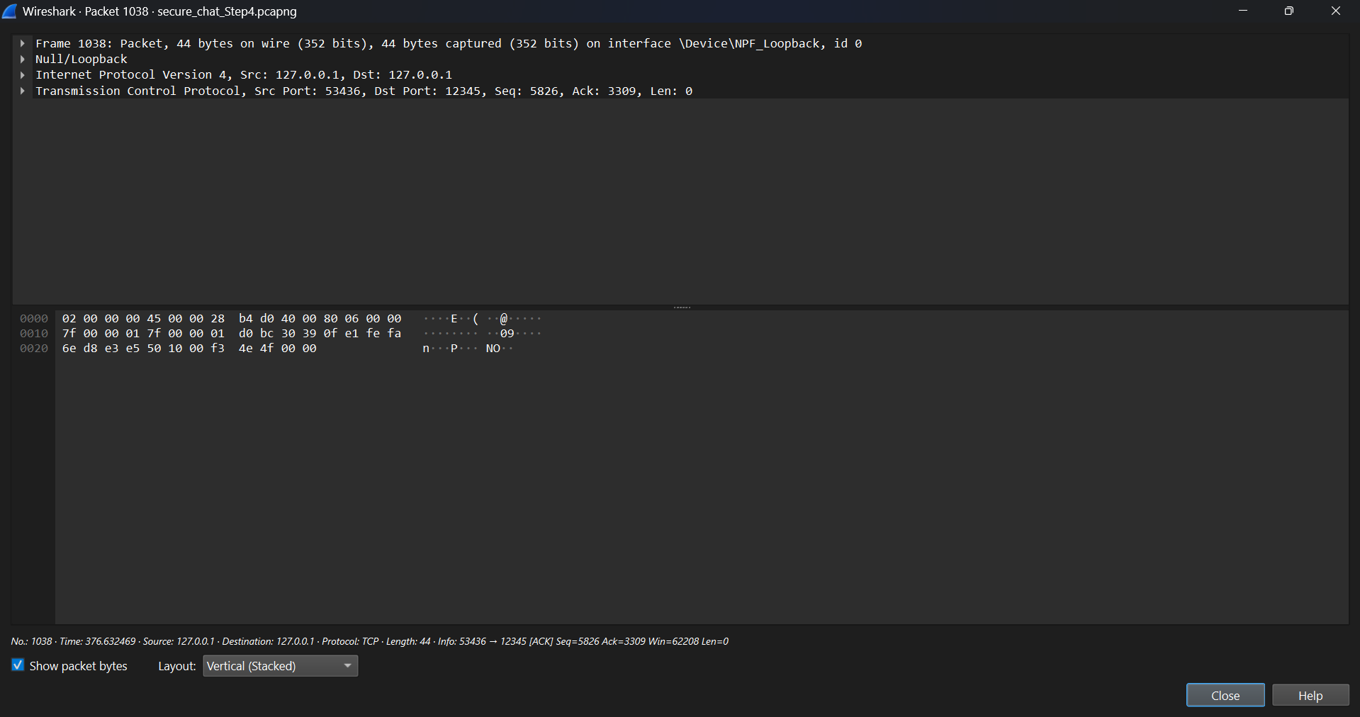

Step 5: Non-Repudiation and Session Closure:

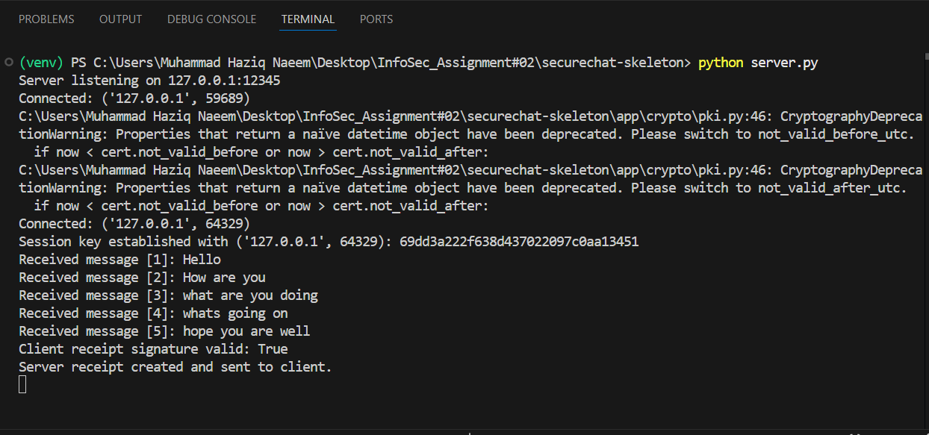

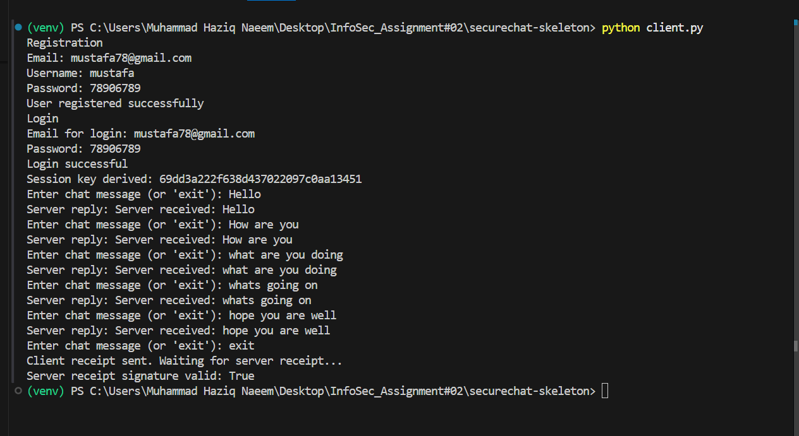

TCP Handshake (Connection Establishment):

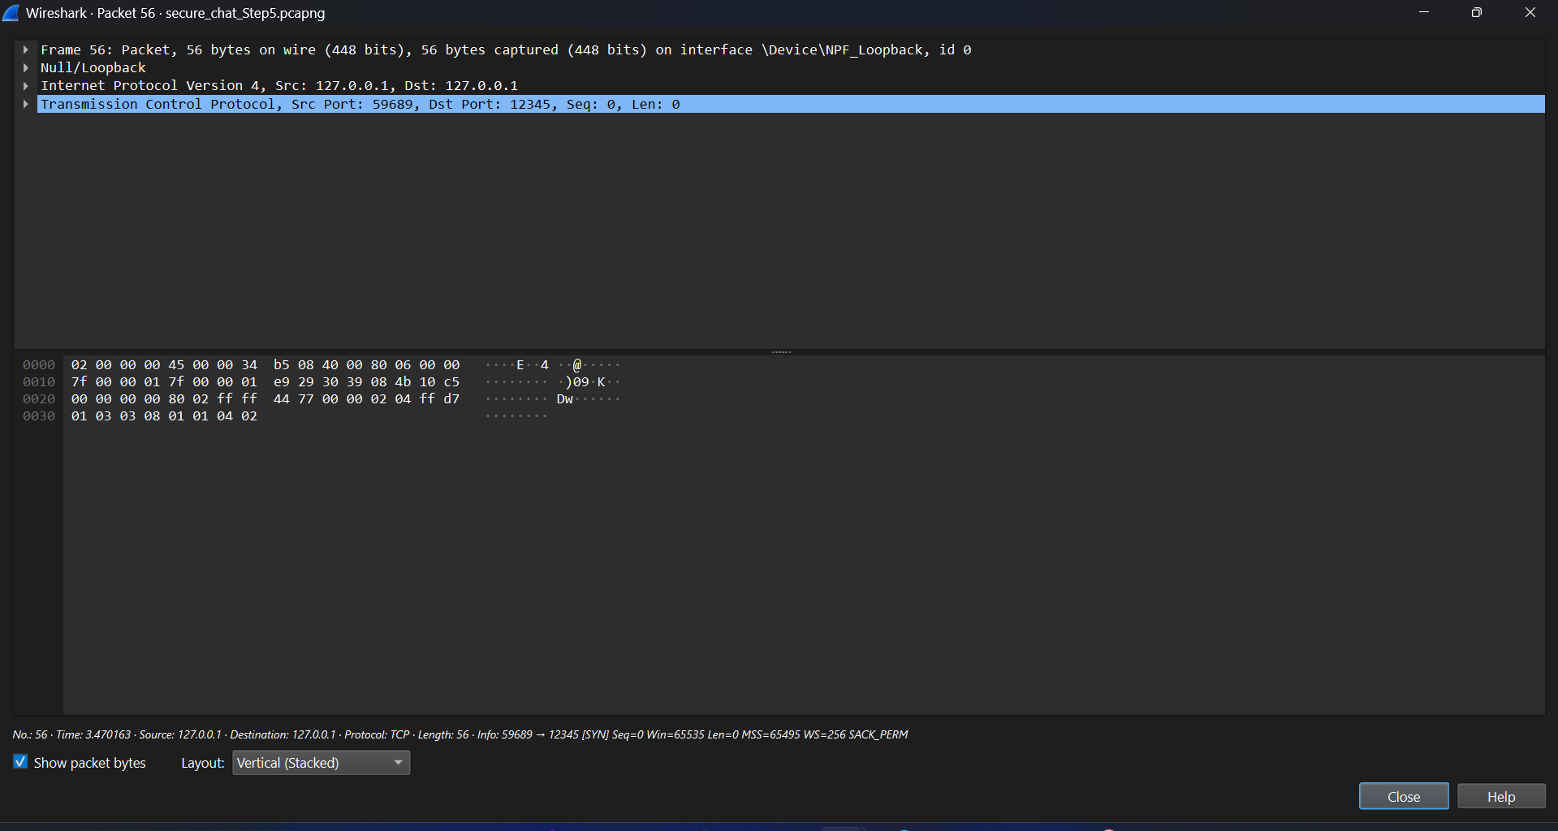

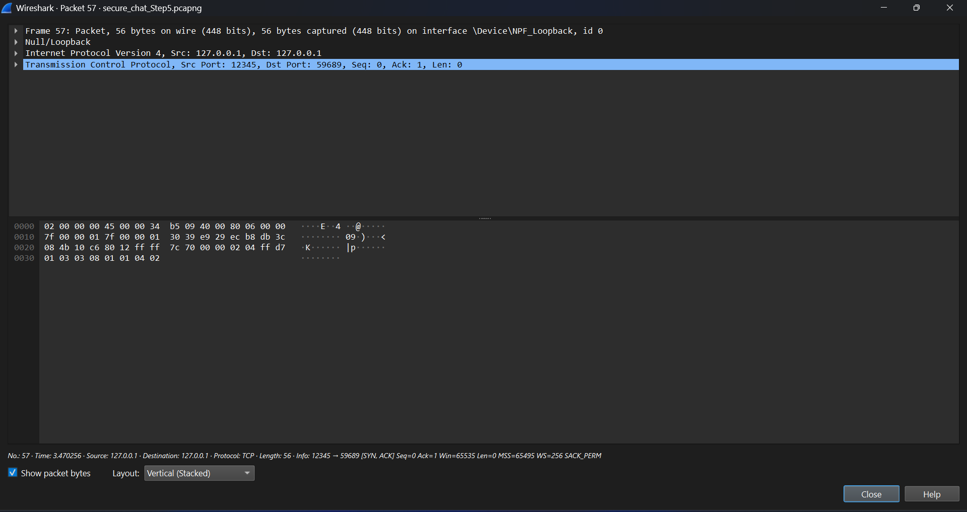

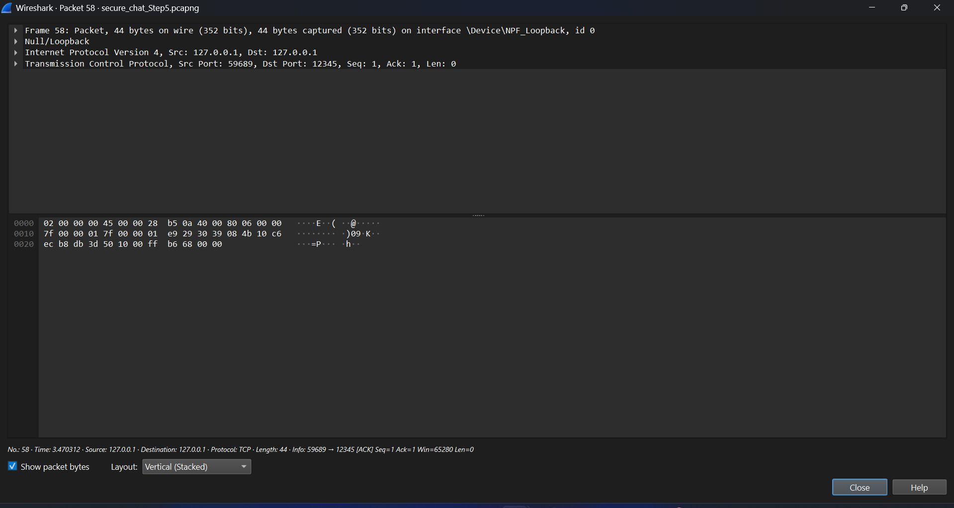

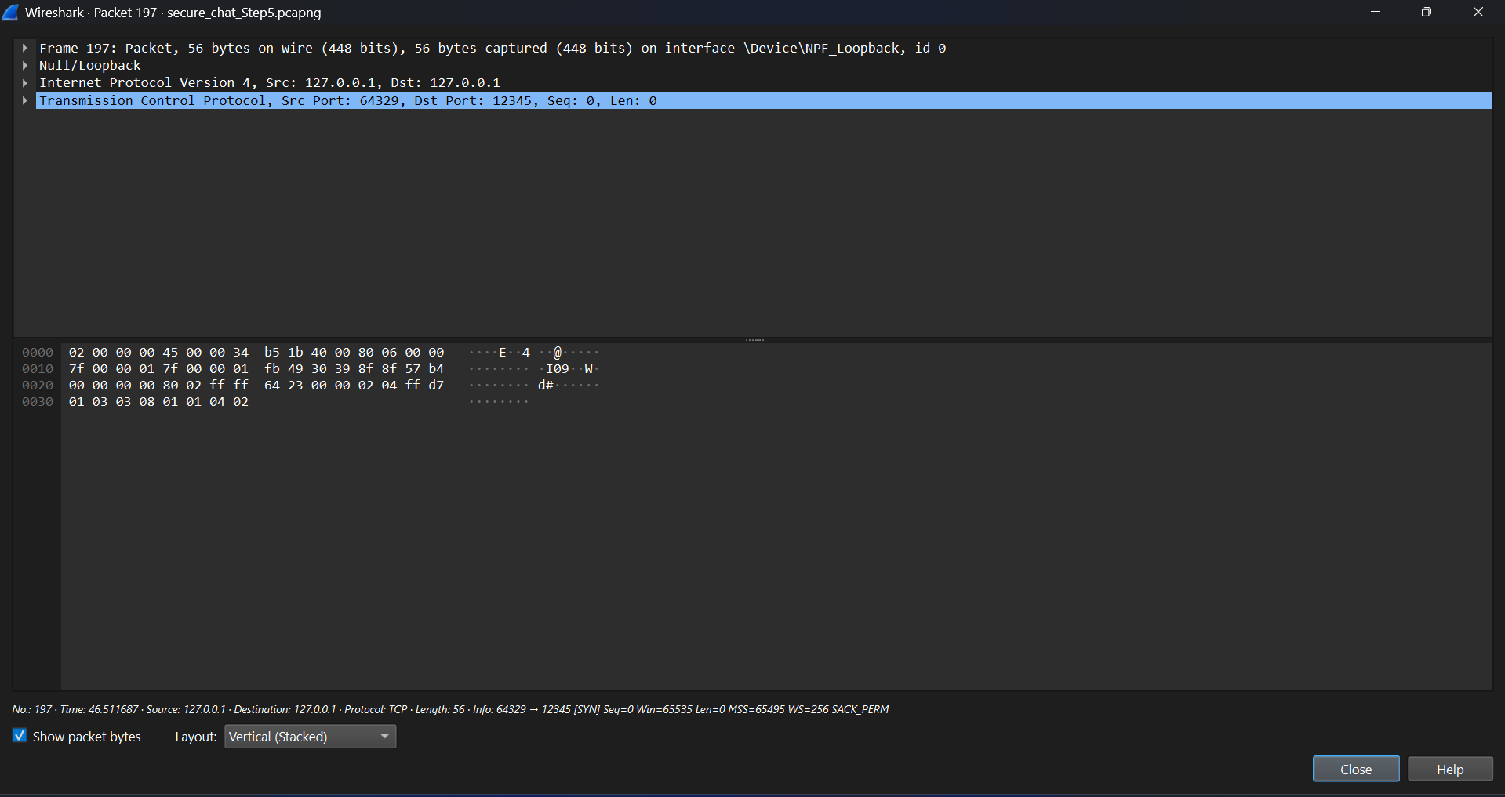

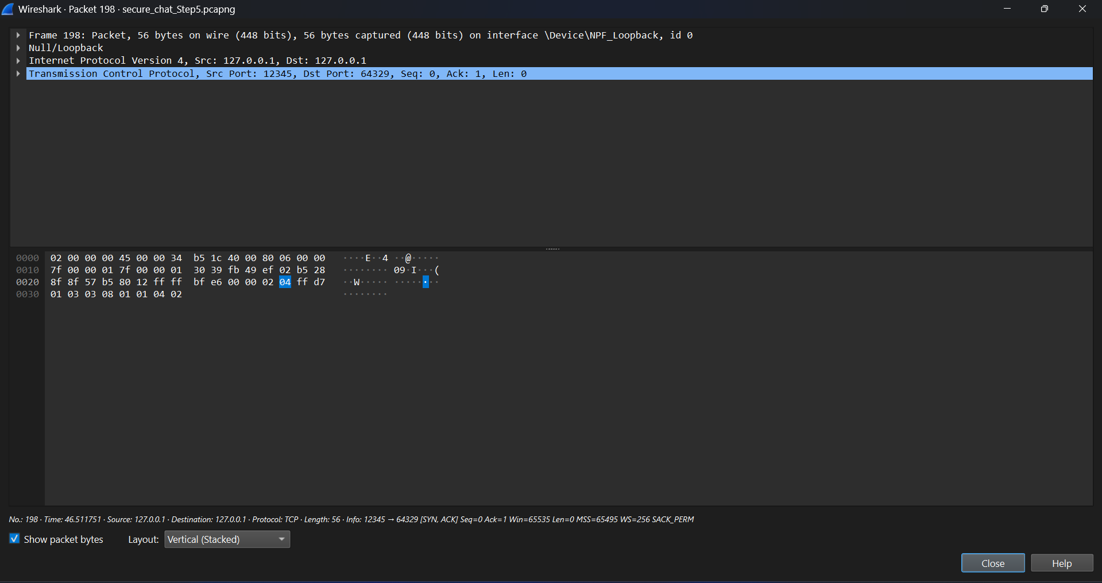

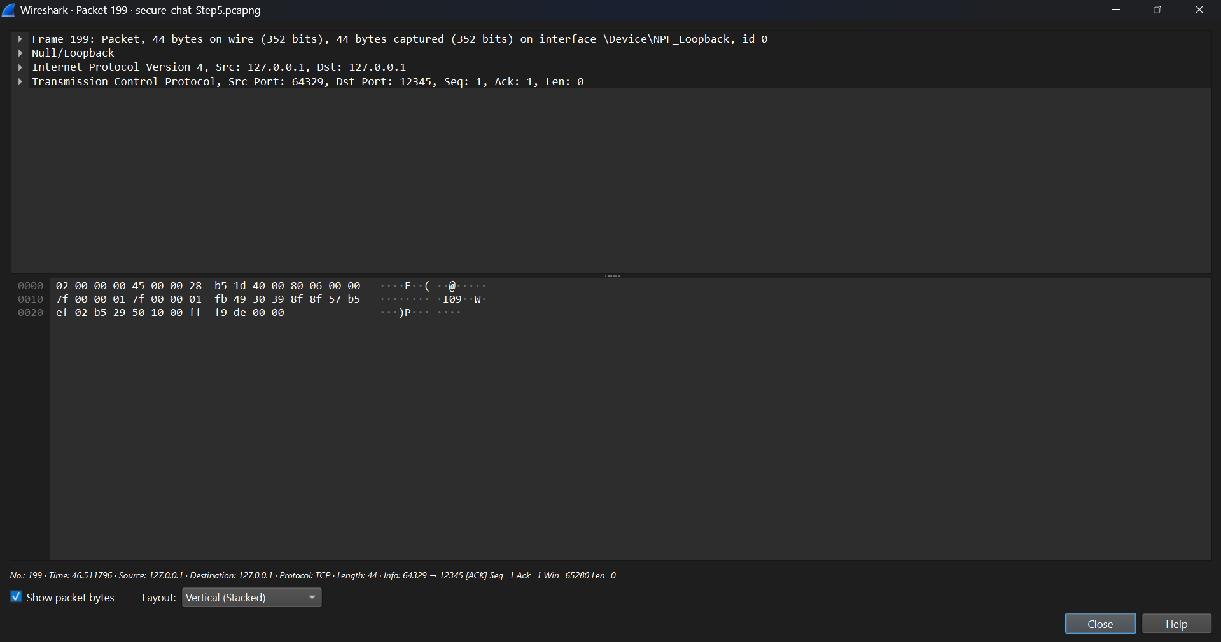

Session Key / Diffie-Hellman Exchang:

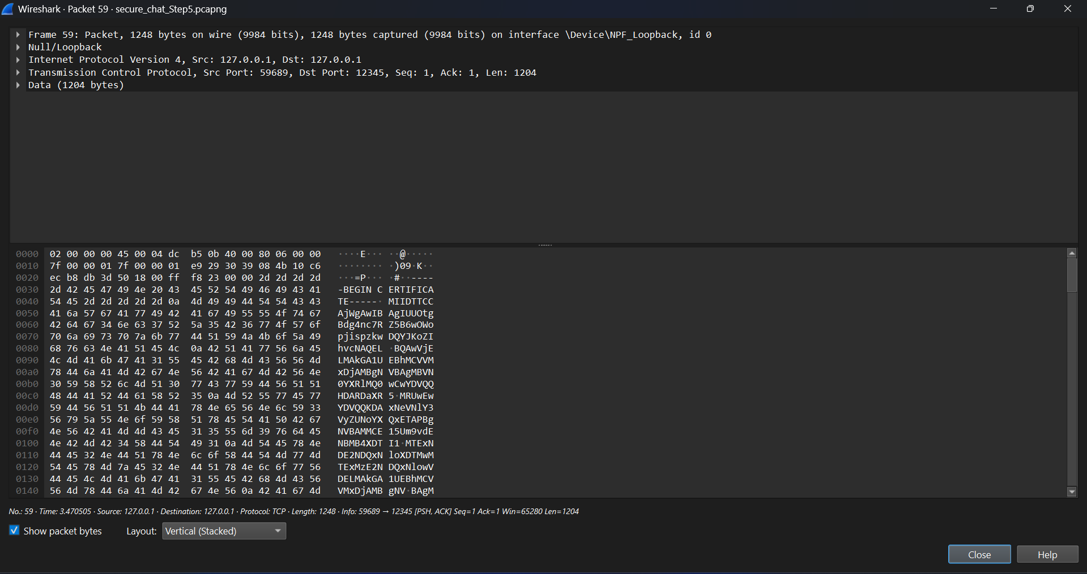

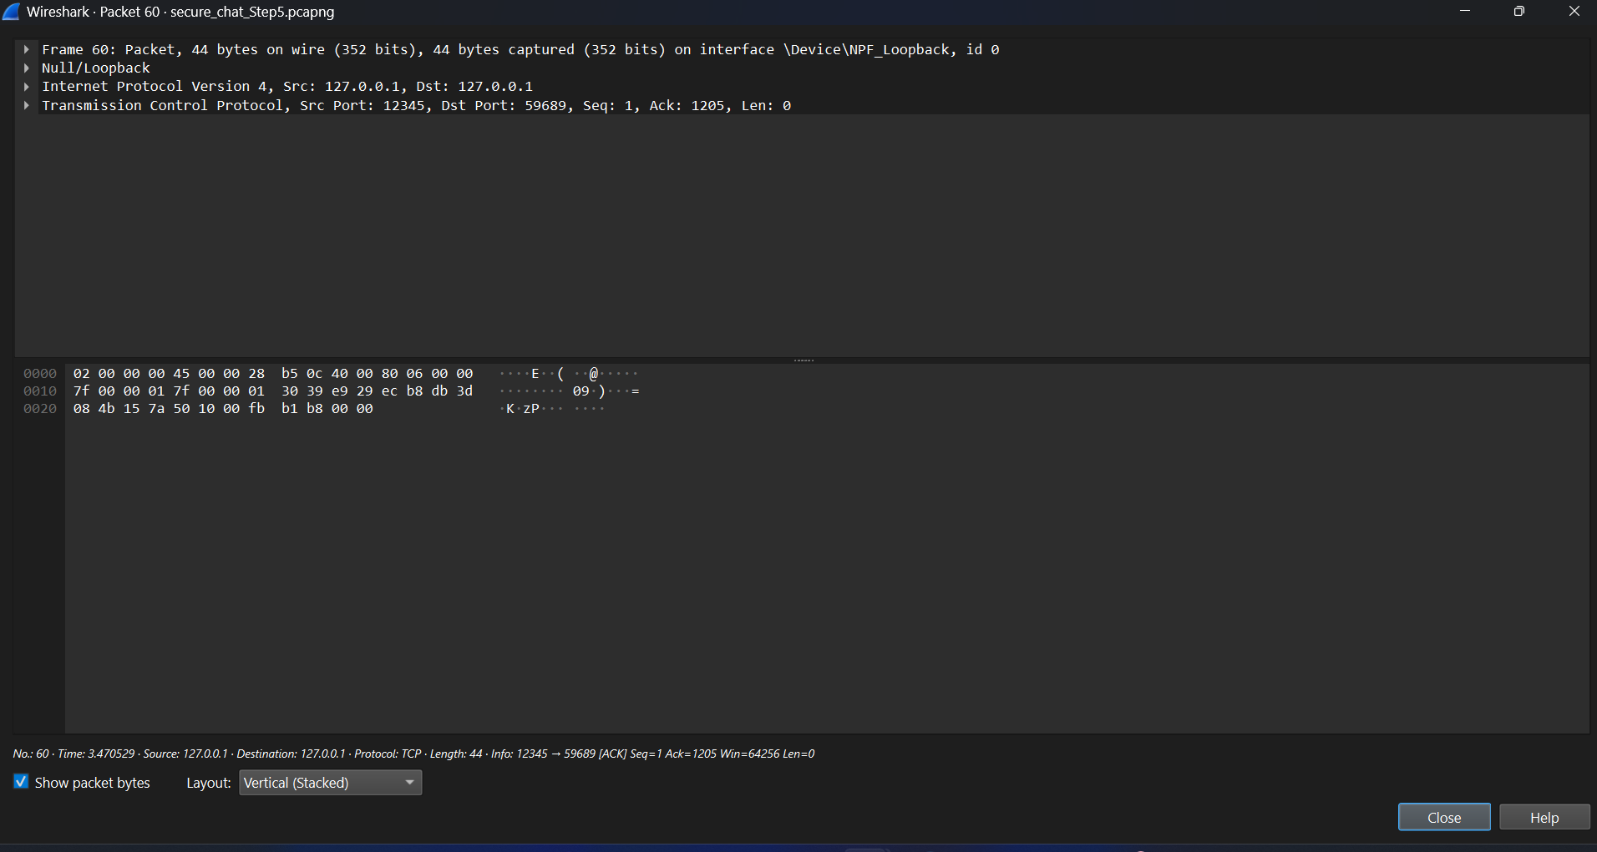

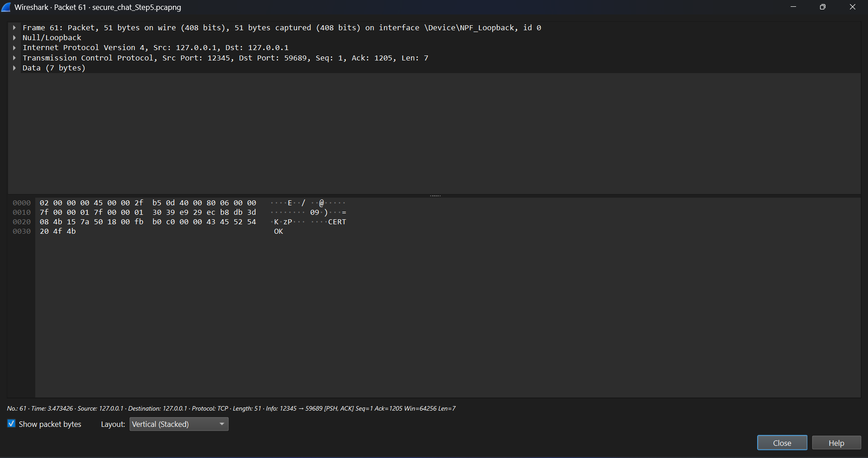

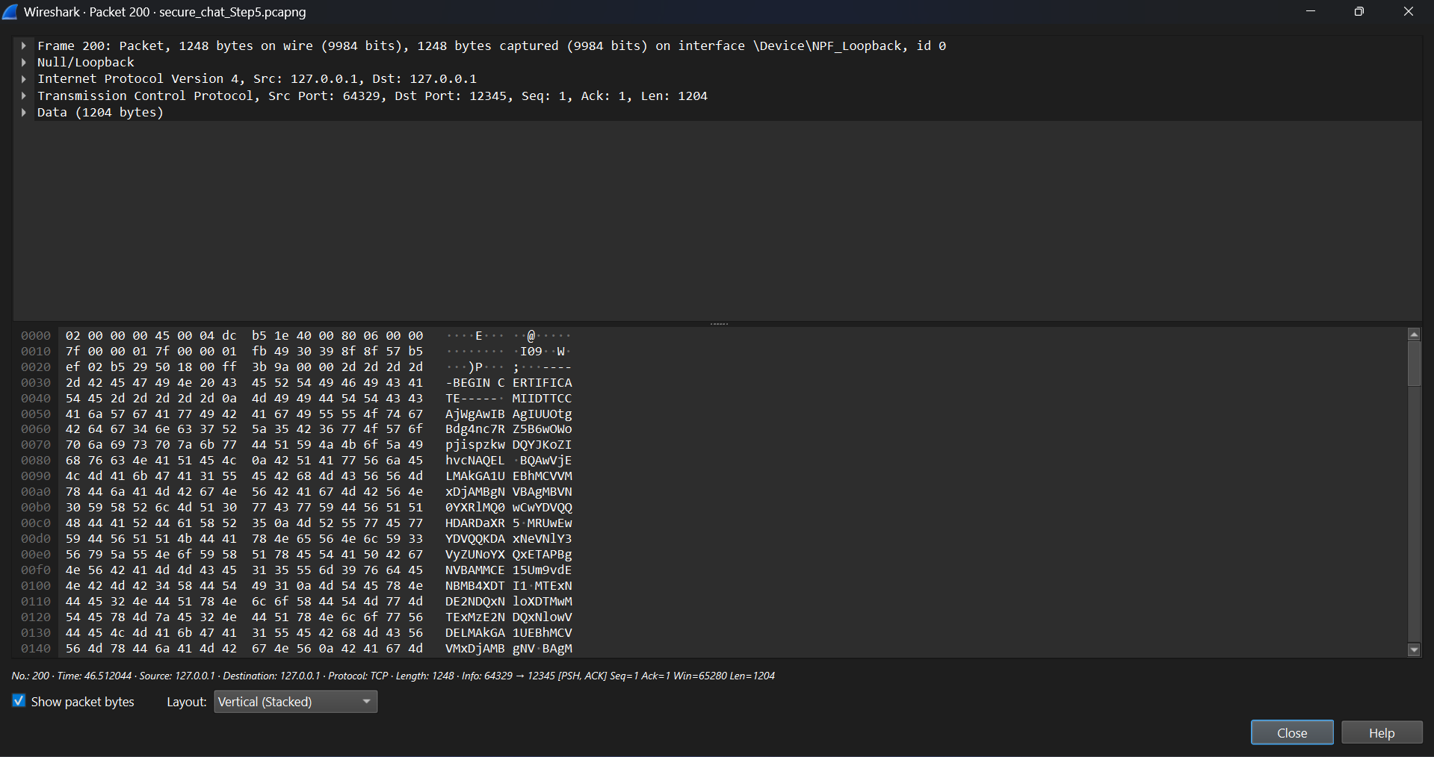

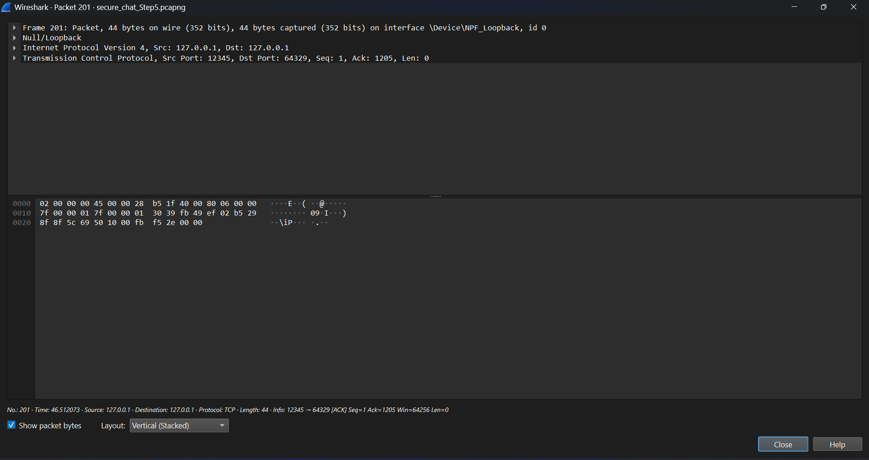

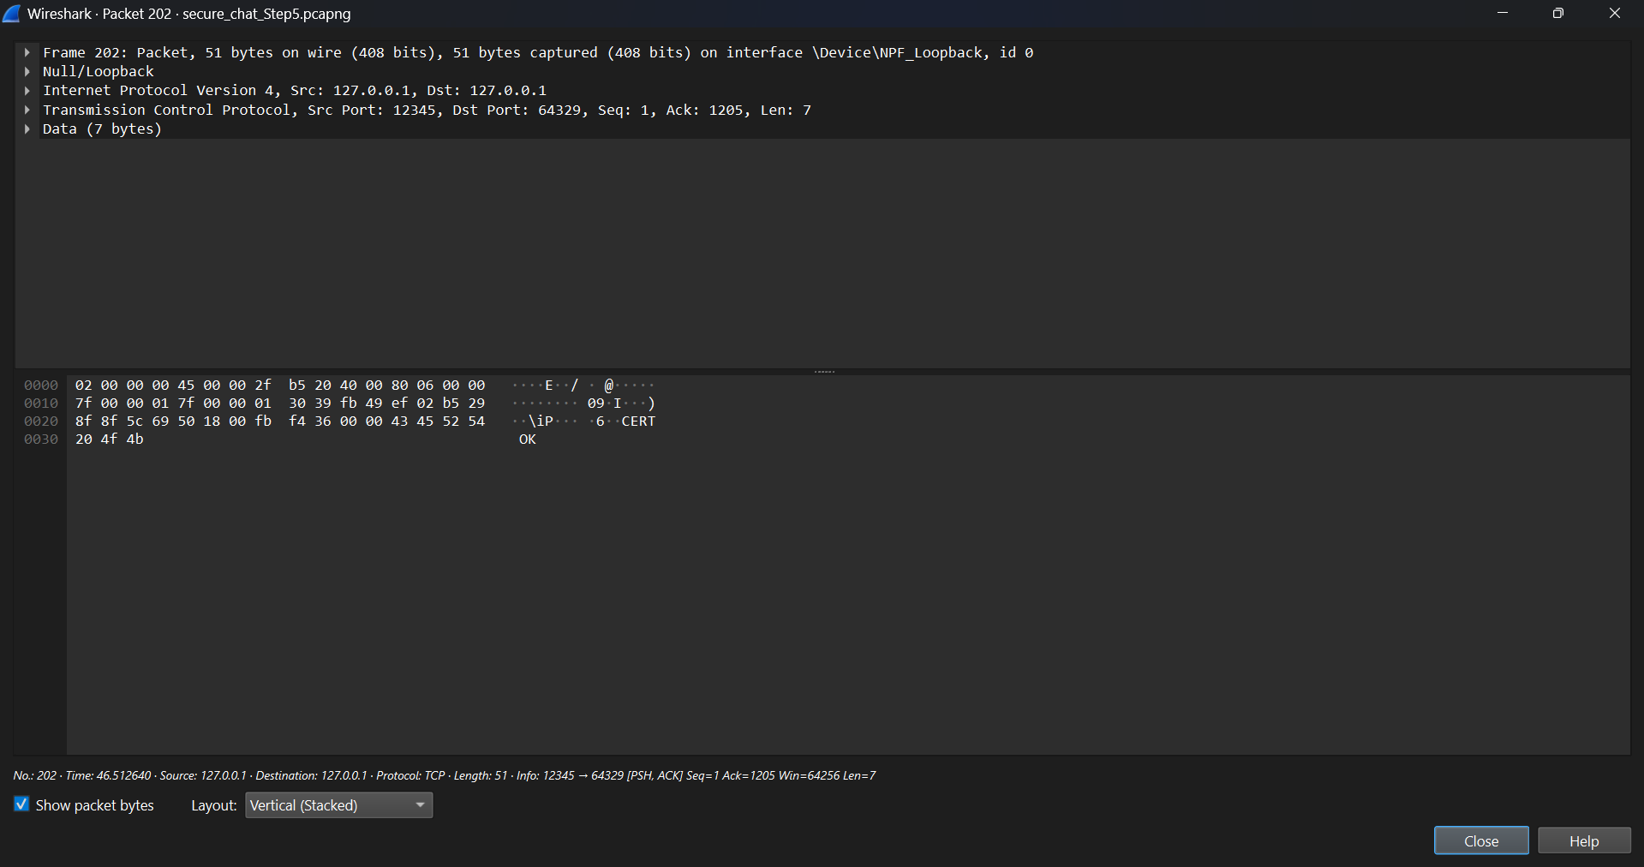

Encrypted Chat Messages:

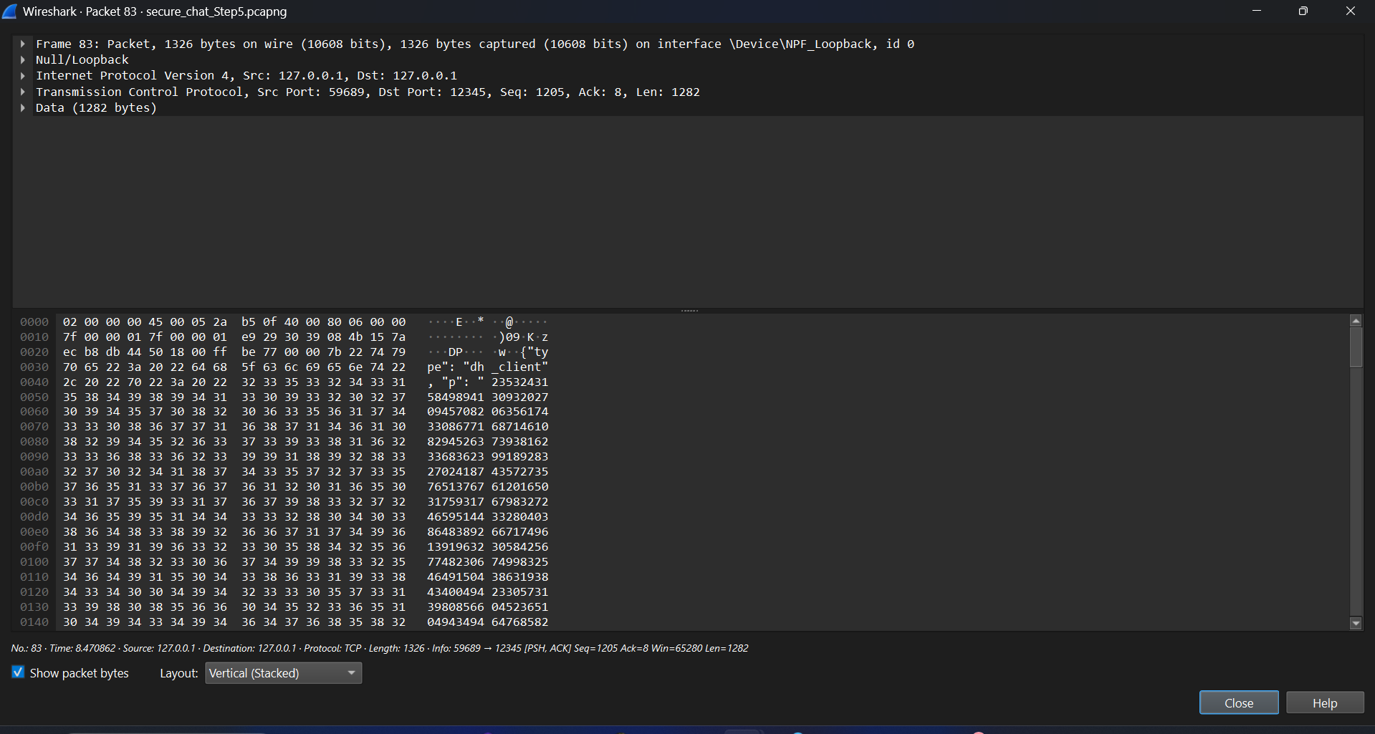

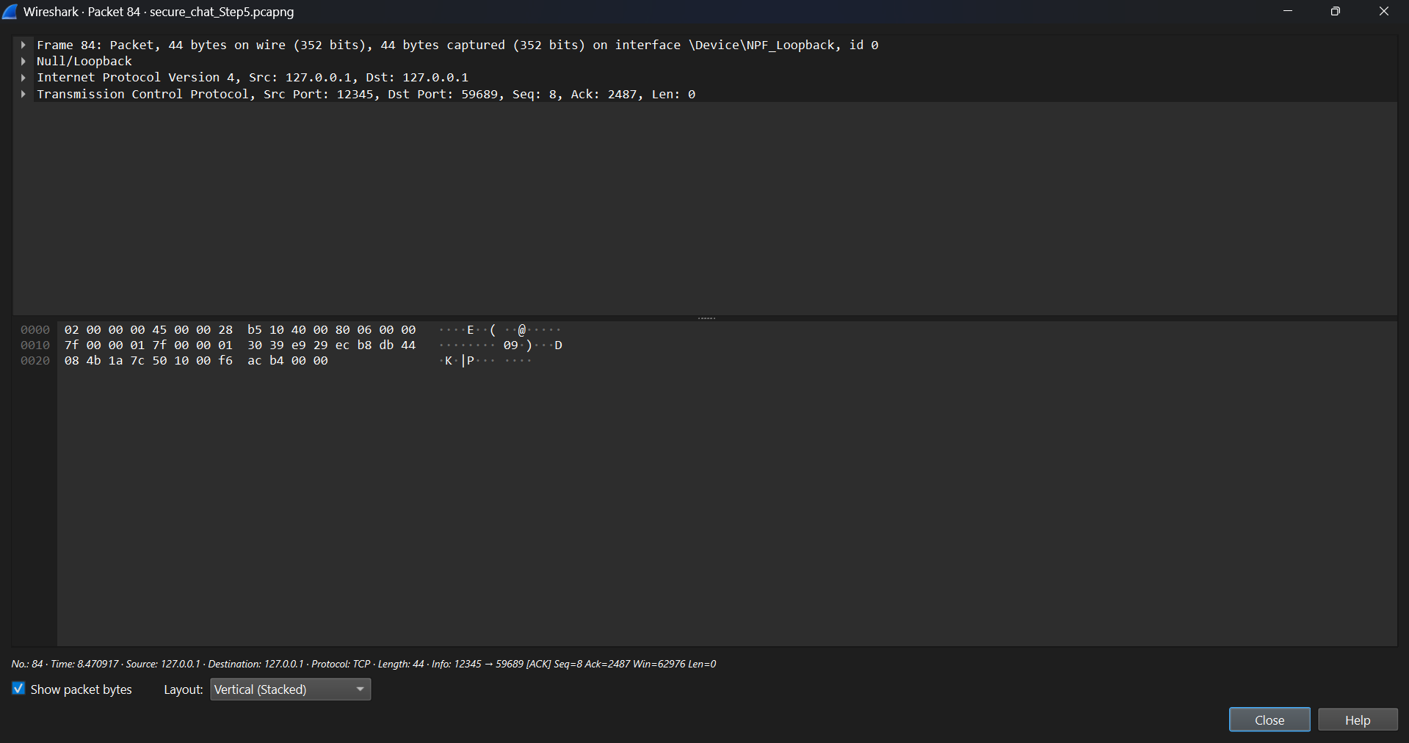

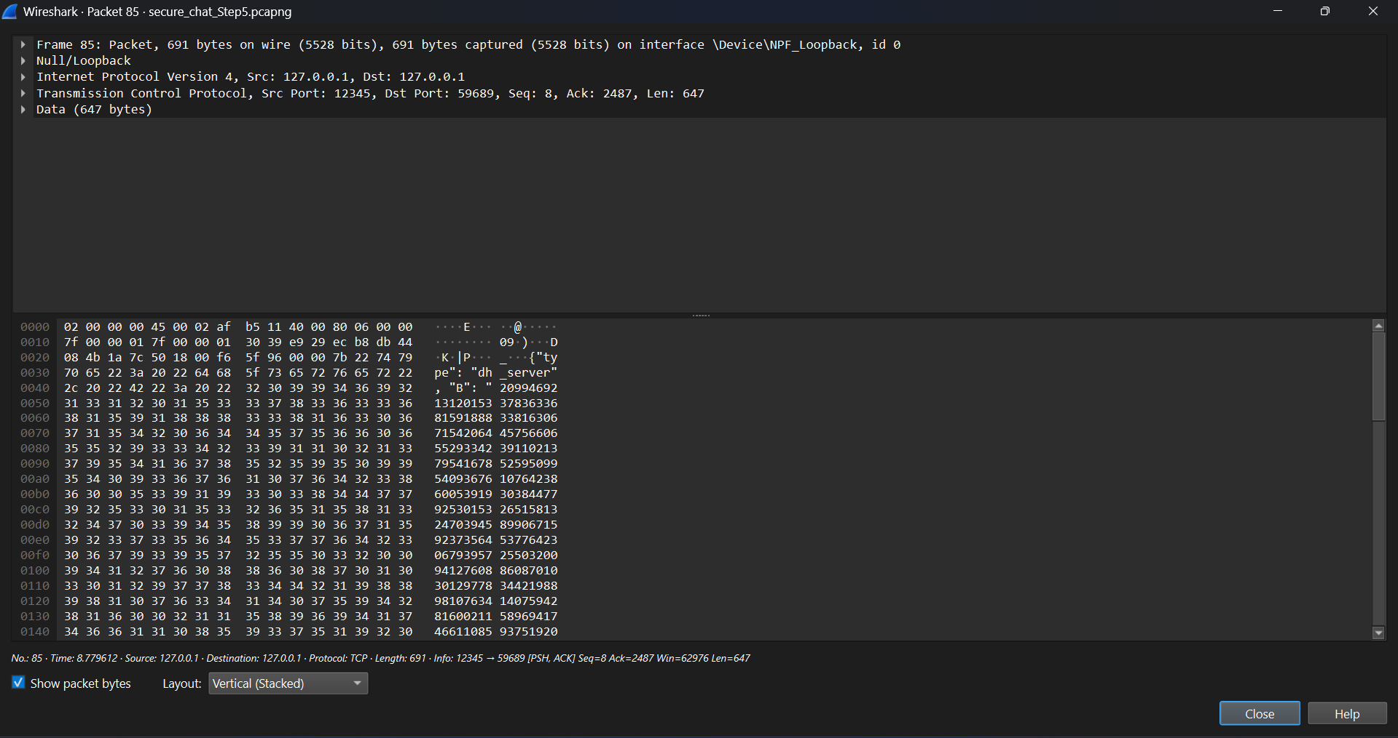

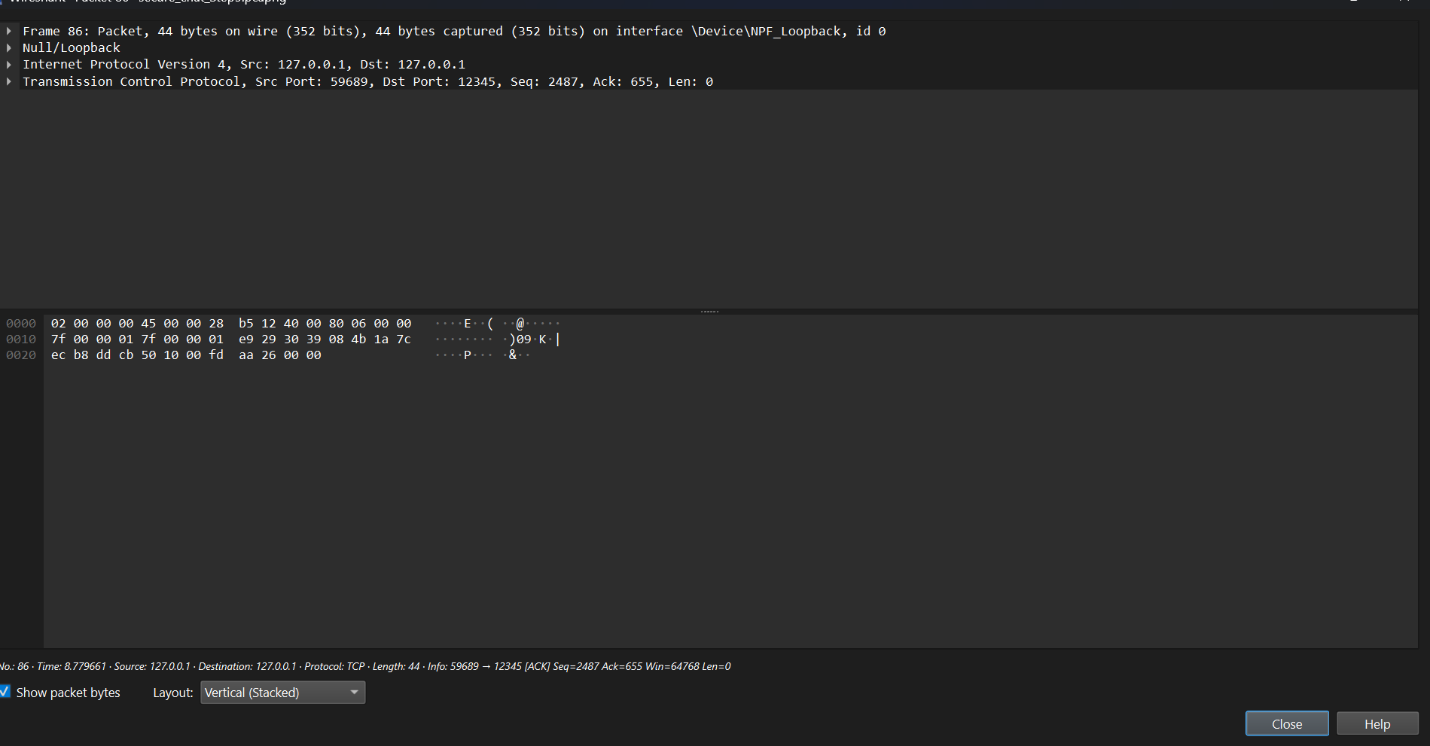

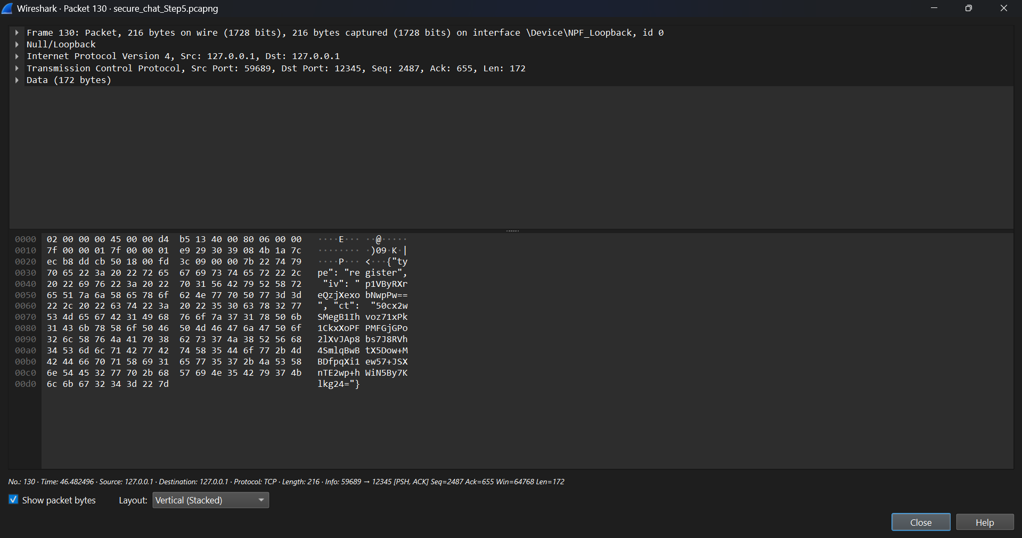

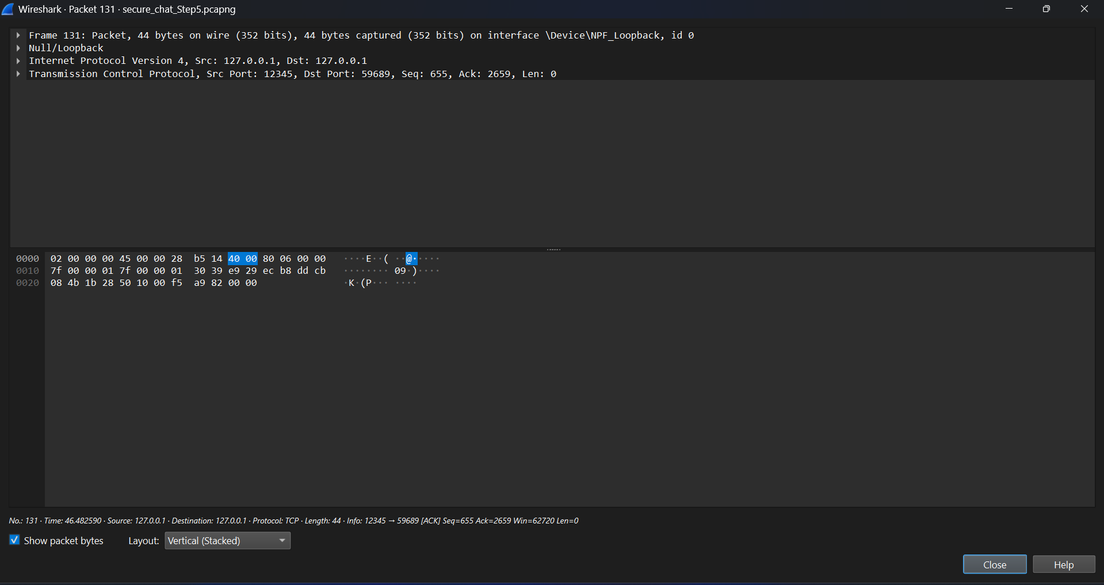

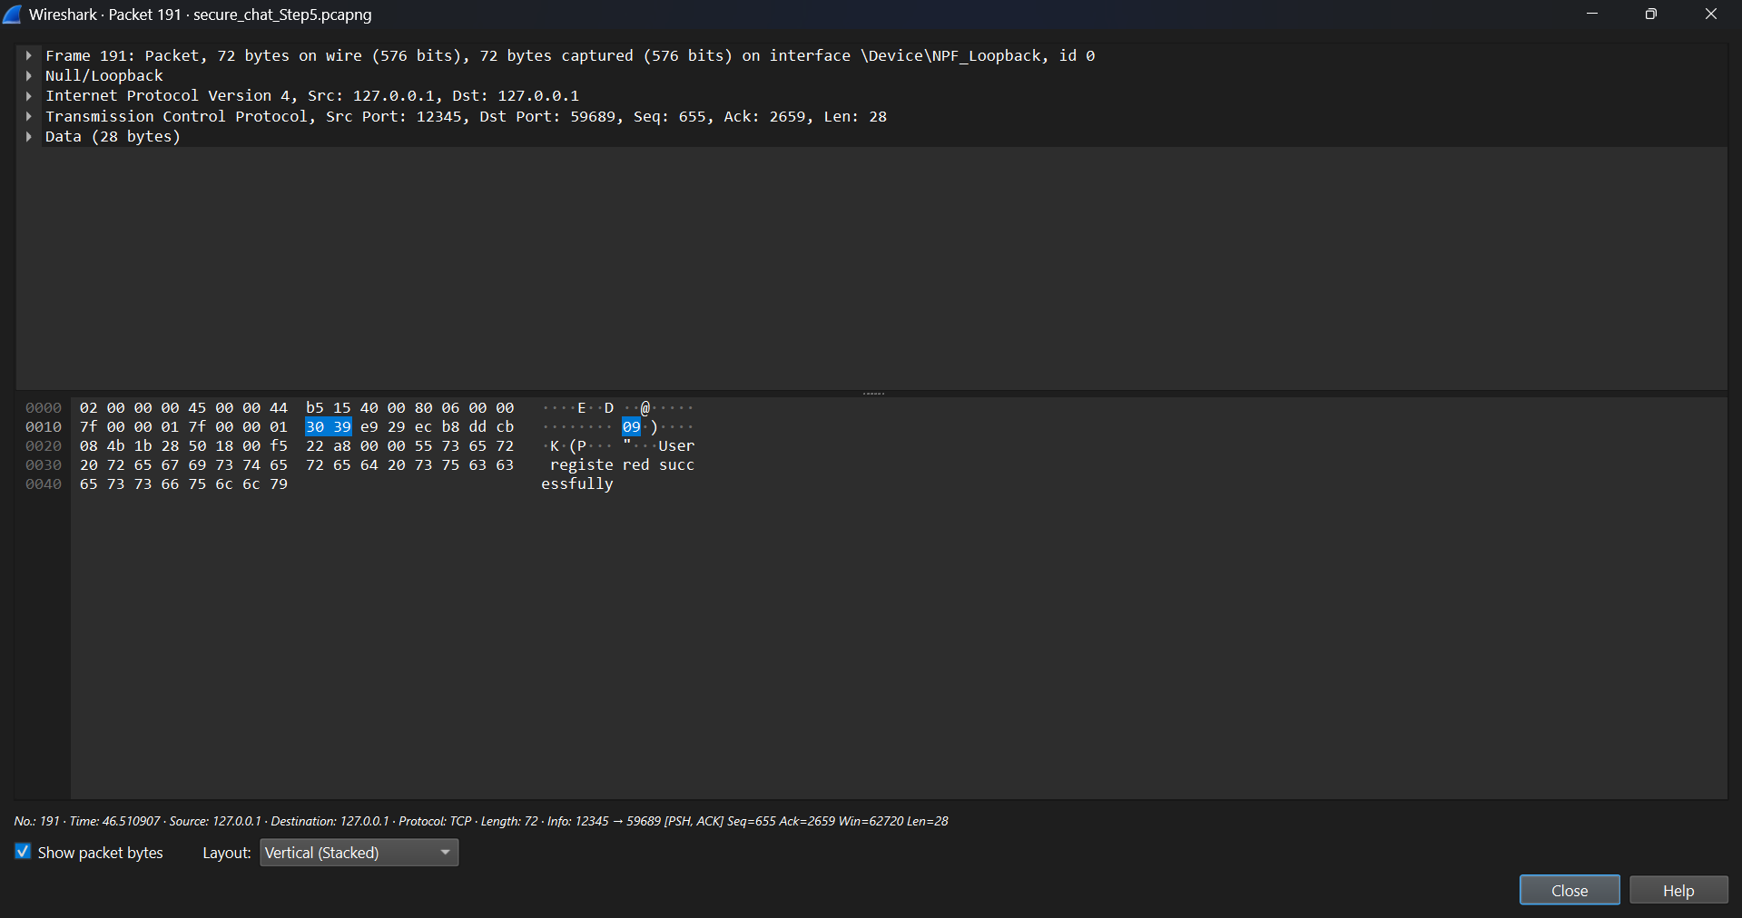

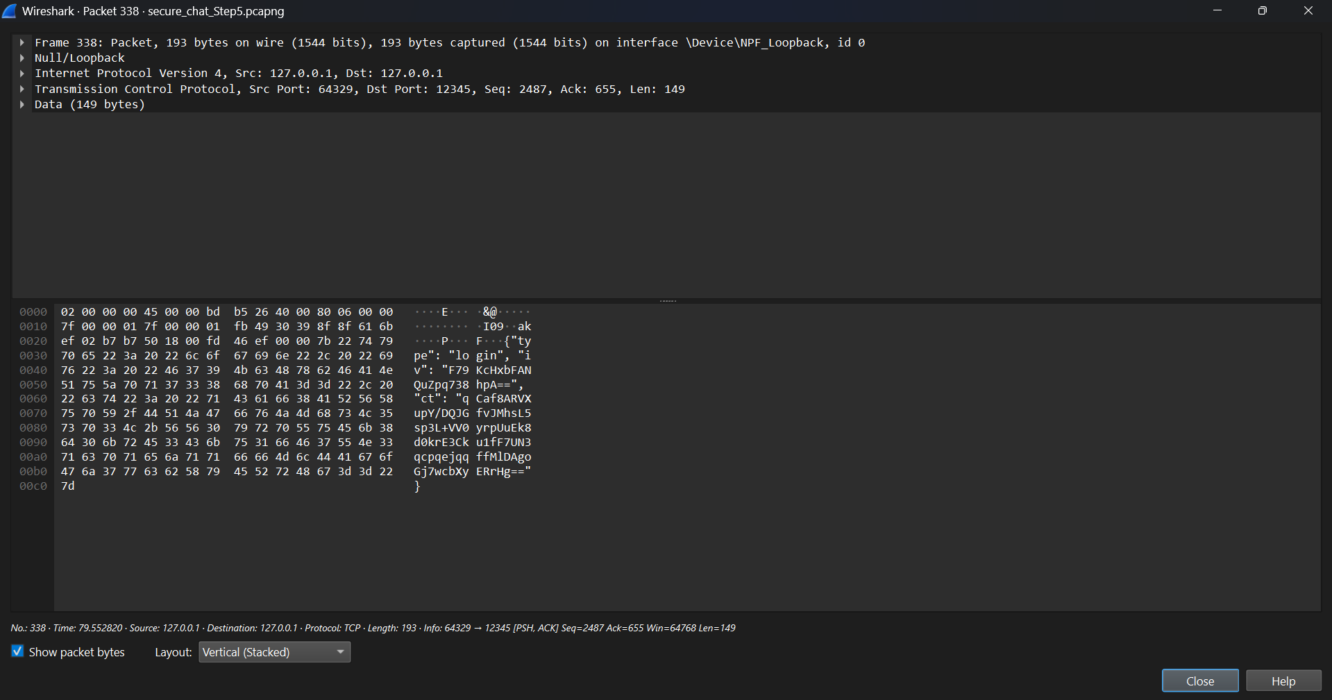

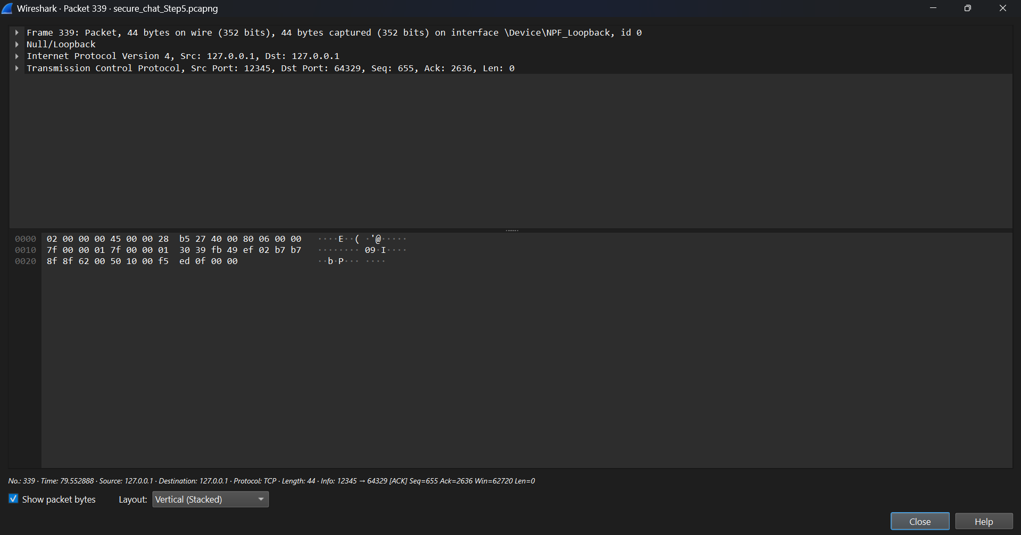

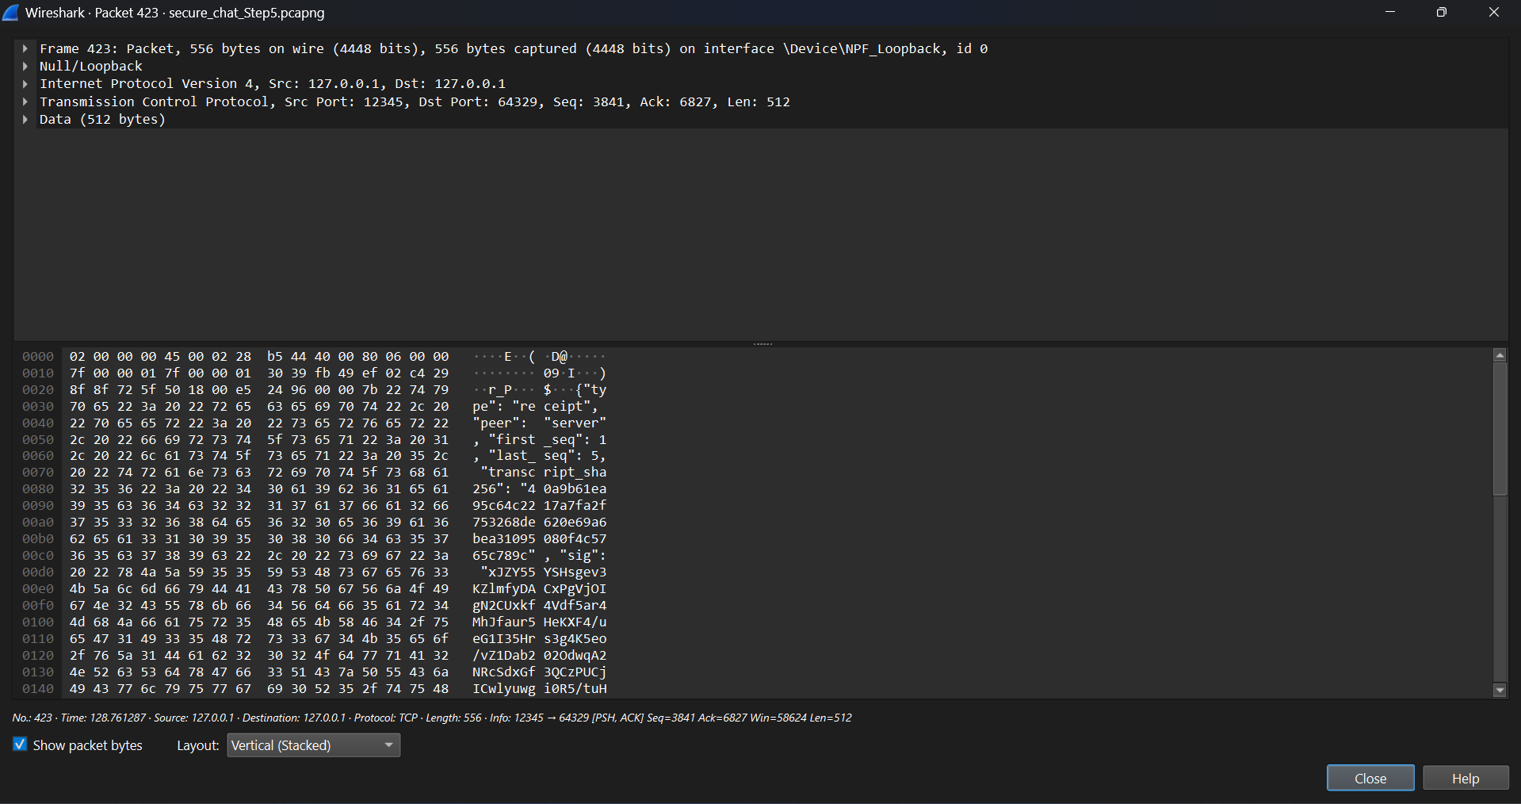

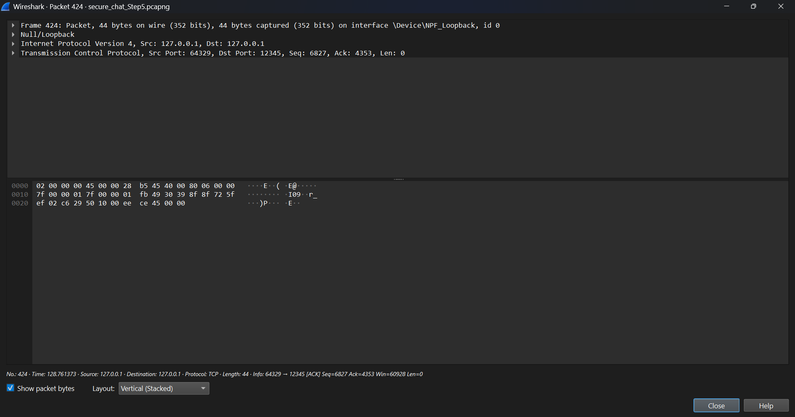

1. **Invalid Certificate Test:**

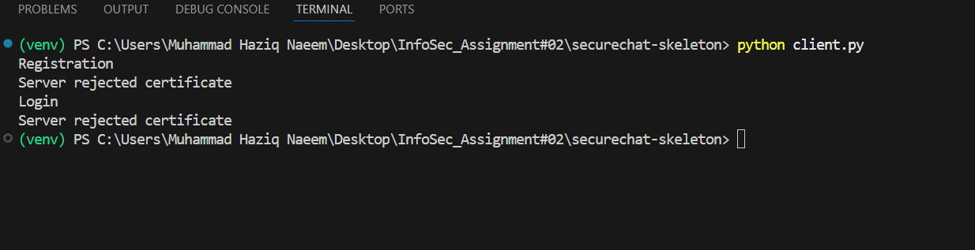

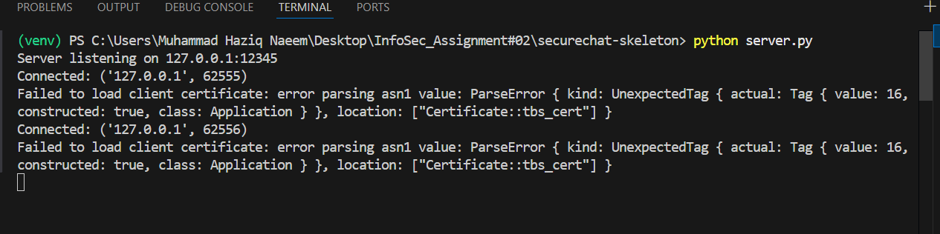

The client’s valid certificate was replaced with a invalid certificate (client_bad.crt).  
During the handshake, the server detected the certificate was invalid and rejected it.  
The server sent a **BAD CERT** message and immediately closed the connection.  
This confirms that invalid certificates are correctly detected and the session is terminated.

1. Tampering test:

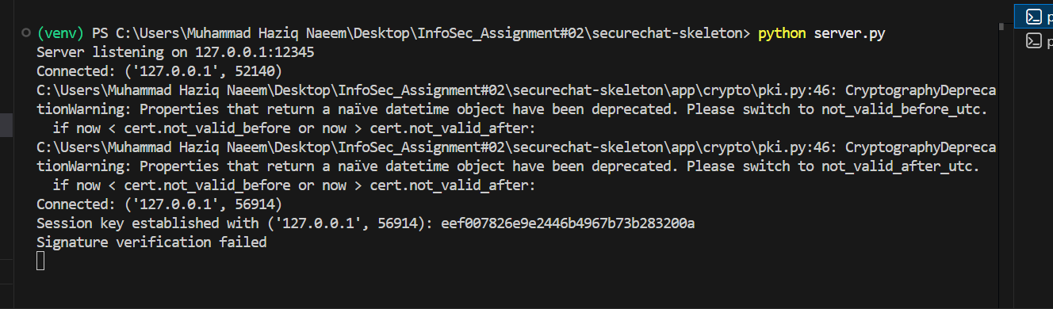

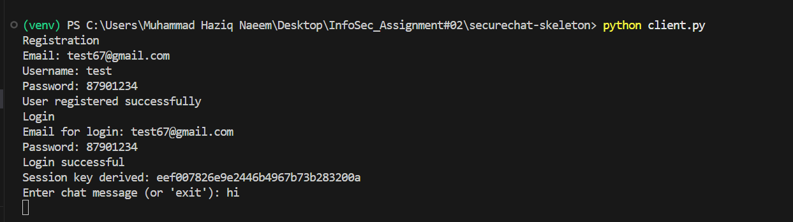

After a successful login, we intercepted the outgoing encrypted message from the client and flipped a bit in the ciphertext. The digital signature was not updated, so the server recomputed the digest using the tampered ciphertext and found a mismatch with the original signature. As expected, the server rejected the message and displayed “Signature verification failed”, proving message-integrity protection is working.

1. **Replay Test:**

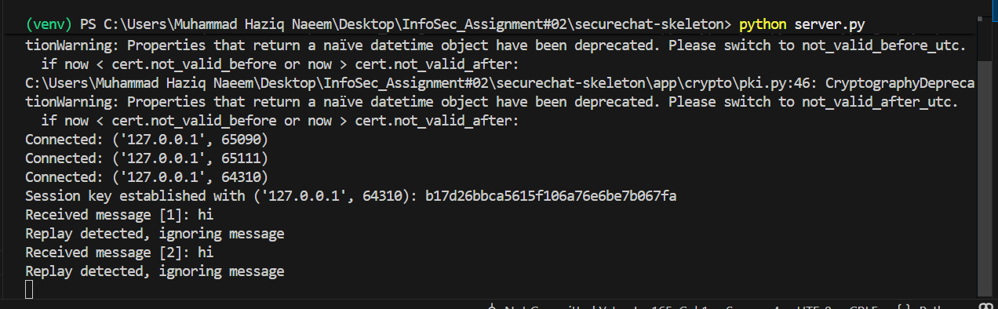

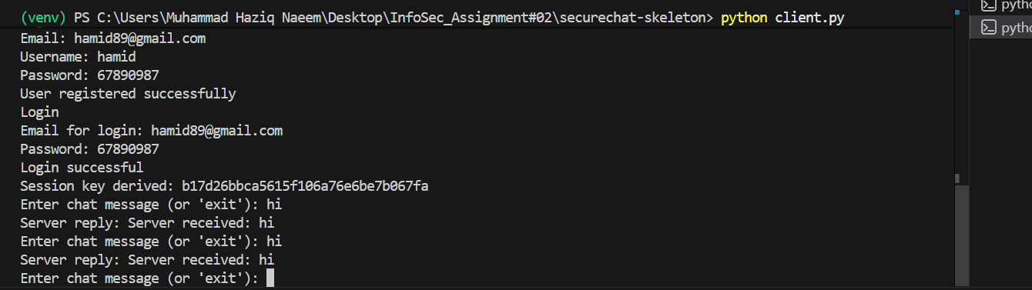

In the Replay Test, the client resent an old message with the same sequence number. The server compared the incoming seqno with the last received seqno and detected that it was not greater. The server printed “Replay detected, ignoring message”.

1. **Non-repudiation:**
2. **Verify each message: recompute SHA-256 digest; verify RSA signature:**

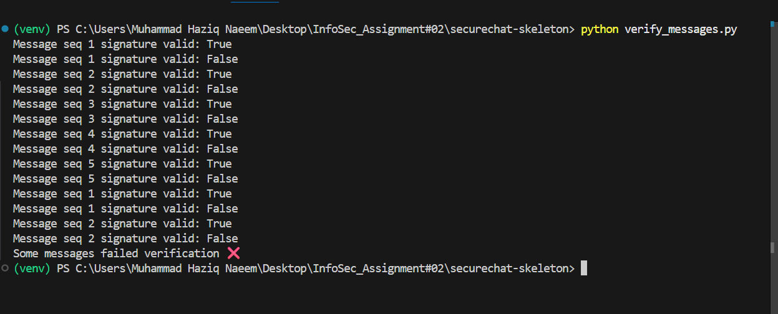

Each message in the session transcript was verified by recomputing the SHA-256 digest and checking the RSA signature using the sender’s public key. Any modification to the message content caused the signature verification to fail, demonstrating message integrity and authenticity.

**2. Verify receipt: verify RSA signature over TranscriptHash:**

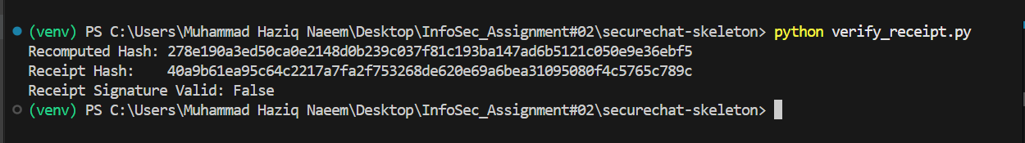

The server transcript hash was recomputed from the saved server_transcript.log, and the SessionReceipt signature was verified using the server’s public key from server.crt. The verification confirmed that the transcript was authentic and untampered. Any modification to the transcript invalidated the receipt signature, demonstrating integrity and non-repudiation.

1. **Show that any edit breaks verification:**

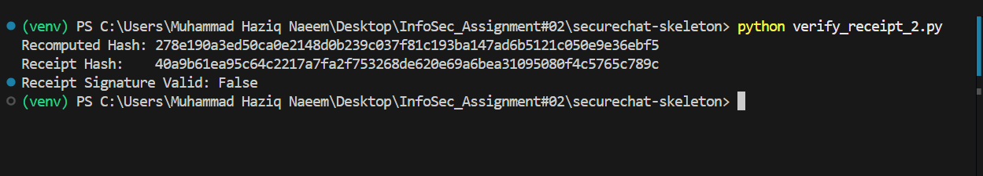

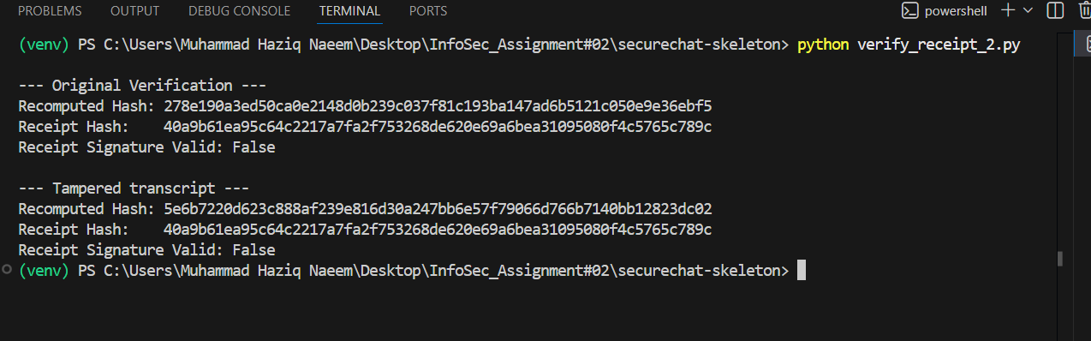

The server transcript and receipt were verified using the RSA public key extracted directly from the server certificate. The SHA-256 digest of the transcript matched the receipt hash, confirming integrity and authenticity. Any modification of the transcript would result in a verification failure, demonstrating non-repudiation.